CIS-481: Introduction to Information Security
Module 5 – Incident Response and Contingency Planning
Exercise #9

Team:
Participants: Dane Froelicher, Ben Siebe, Ethan Troutman, Isaiah Collins, Alexandra Brooks

Logistics

- Get together with other students on your assigned Team in person and/or virtually.
- Discuss and complete this assignment in a collaborative manner. Don’t just assign different problems to each teammate as that defeats the purpose of team-based learning and may impact your performance on assessments, especially with respect to the essay questions.
- Choose a scribe to prepare a final document to submit via Blackboard for grading, changing the file name provided to denote the number of your assigned Team.

Problem 1 (10 points)
Refer to Figure 5-4 from the text and answer the following.

- Explain each of the following key recovery measures: Recovery Point Objective (RPO), Recovery Time Objective (RTO), Work Recovery Time (WRT), and Maximum Tolerable Downtime (MTD). (2 pts. each)

Recovery Point Objective is the maximum amount of time a system can be down before it starts to create an unacceptable impact on the resource systems, and business processes. Recovery Time Objective is the maximum amount of time that the system can be down before the data from the business processes can be restored based on the recent backup copy. Work Recovery Time is the amount of work it will take to restore the business processes after the technological elements of the process are restored. Maximum Tolerable Downtime is the maximum amount of time the system owner will allow the business processes to be down.

- Is it possible to have an RTO of 0? What would be required to achieve near immediate recovery? (2 pts.)

It is possible to have a Recovery Time Objective of 0, where a system must be able to be recovered immediately. To be able to do this, a business would need to invest in a fully redundant alternative processing site that could be switched over to. Achieving low RTO’s, especially 0, is expensive.

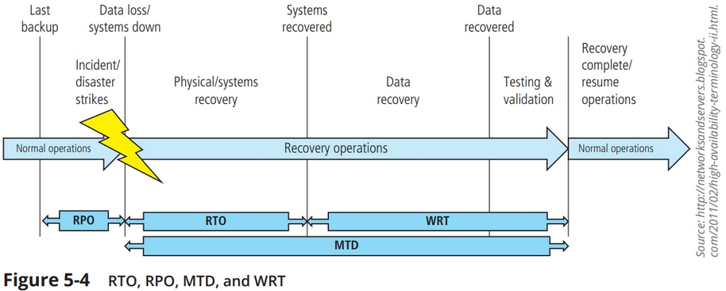

Problem 2 (10 points)
Classify each of the following occurrences as an incident or disaster. If an occurrence is a disaster, determine whether business continuity plans would be called into play. Briefly explain your reasoning for each. (2 pts. each)

- A hacker breaks into the company network and deletes files from a server.

This would be considered an incident since the result is a loss of information assets, but the company likely has backups of the files so it may not harm the viability of the organization.

- A fire breaks out in the storeroom and sets off sprinklers on that floor. Some computers are damaged, but the fire is contained.

This would be considered an incident since information assets would be lost on the damaged computers, but the fire was contained and only affected those computers. The company can replace those computers and reload any data that was previously backed up, so the company can quickly recover from this.

- A tornado hits a local power station, and the company will be without power for three to five days.

This is a disaster since the company can’t control exactly how long the power station will be affected. Business continuity plans may be called into play depending on the size or importance of the affected location – if the company can’t function without this location, the business continuity plan would be used to determine whether business functions can be resumed at a cold, warm or hot site.

- Employees go on strike, and the company could be without critical workers for weeks.

This would be a disaster because the company cannot run as usual or quickly handle the situation. They have no control over when the employees will choose to come back and there's no way to have replacements on call that fast. A business continuity plan would have to come into place to produce the most efficient solution to get things back on track as soon as possible.
- A disgruntled employee takes a critical server home, sneaking it out after hours.

This would be considered an incident with the potential of information assets being lost. It is only an incident because the employee is only taking whatever is on that specific server. The company can account for what is being lost and know exactly what this employee has in their possession.

Problem 3 (5 points)
What is digital forensics and when is it used in a business setting?

Digital forensics is a forensic science that processes, analyzes, and reports on data stored electronically. The most likely use of digital forensics would be part of the company's incident response protocol. An in-depth analysis of the incident and to find out who or what was responsible. Another likely use would be identifying any possible cyber-attack on the company's system.

