Lab: DB Pen Testing with Kali Linux

Tasks

1. Retrieving MS SQL server information
Task: Retrieve MS SQL server information like below. Explain how you were able to overcome the filtering. Also, provide the result like below in a screenshot (Screenshot #1).
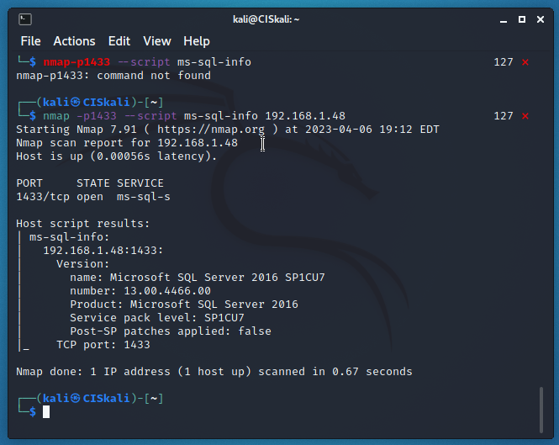
I was able to overcome the filter with the nmap script allowing the attacking machine to tab into SQL. Also, the firewalls on the windows computer is also disabled.

2. Brute forcing MS SQL passwords
Task: Display the result in a screenshot (Screenshot #2). Describe what you have accomplished. 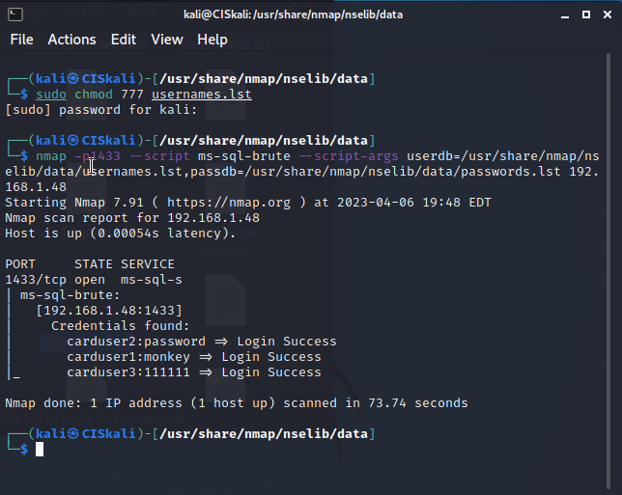
The passwords for the new users inserted into the username,lst were found and logged in successfully.

3. Dumping the password hashes of MS SQL
Task: Display the result in a screenshot (Screenshot #3). 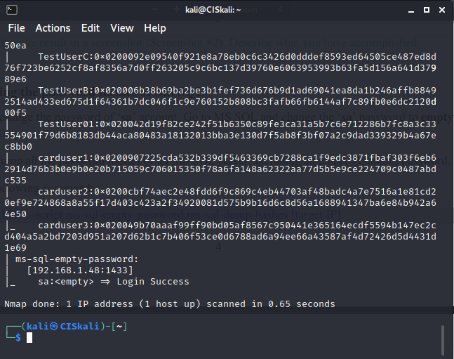

4. Finding sysadmin accounts with empty passwords on MS SQL
Task: Display the result with ‘sa’ account in a screenshot (Screenshot #4).
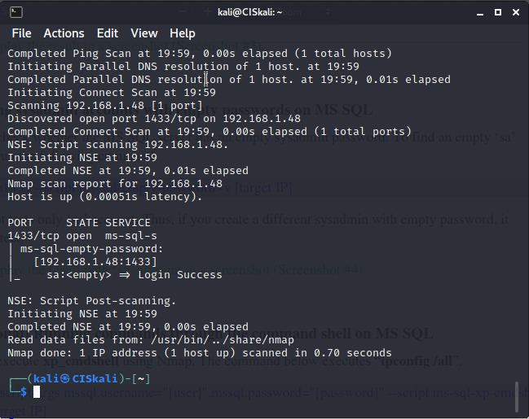

5. Running commands through the command shell on MS SQL
Task: Run the above command using ‘sa’ account with empty password. Display the result in a screenshot (Screenshot #5A).
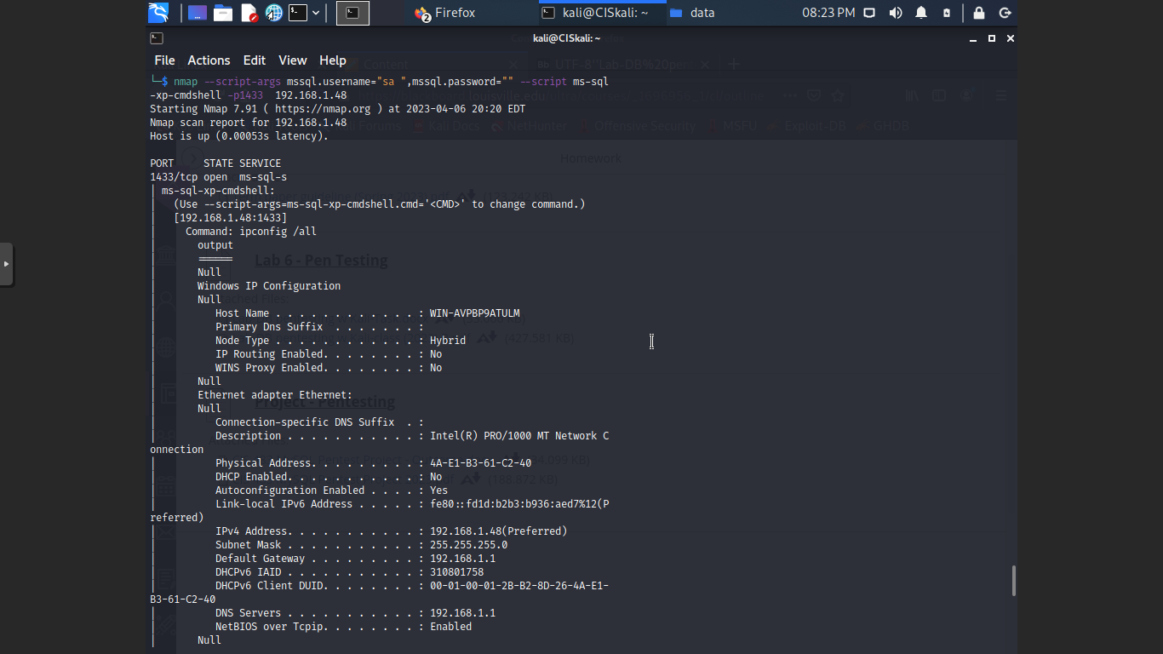

Task: Run the above command using ‘carduser1’ account. Display the result in a screenshot (Screenshot #5B). Why are the results from 5A and 5B different?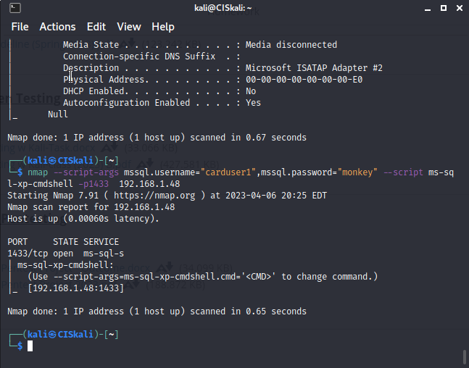
The difference is that in part A it shows all of the system information (as shown in the screenshot) whereas for the carduser1 it does not show any information.

