Blue Ridge Animal Rescue and Sanctuary Website Development

Project Management Plan
Version 2.0
4/28/2023

Team GP Aye
Alexus Maddox, Ethan Troutman, George Flarsheim, Kelechi Ragland, Rob DeVoto

Document Control

Document Information
© | Information
Document Owner | Team GP Aye
Issue Date | 2-2-2023
Last Saved Date | 4-28-2023
File Name | Final Project Management Plan.docx

Document History
Version | Issue Date | Changes
1.0 | 2/6/2023 | First Draft
2.0 | 4/28/2023 | Final Document

Document Approvals
Role | Name | Signature© | Date
Project Sponsor | J. David Chrisman
Business Owner | Kim Dehler
Project Manager | Kelechi Ragland
Web Development Manager | Rob DeVoto
Database Manager | George Flarsheim
Security Manager | Ethan Troutman
Security Manager | Alexus Maddox

Table of Contents
1 Executive Summary 4
2 Planning Basis 4
2.1 Scope 4
2.2 Project Charter 4
2.3 Statement of Work 4
2.4 Milestones 4
2.5 Stakeholder Register 5
2.6 Systems Architecture Diagram 5
2.7 Entity Relationship Diagram 6
2.8 User Flow Diagram 7
2.9 Work Breakdown Structure 8
2.9.1 Work Breakdown Structure Organized by Product 8
2.9.2 Work Breakdown Structure Organized by Phase 8
2.9.3 Work Breakdown Structure Dictionary 8
2.10 Requirements Management Plan 9
2.11 Requirements Traceability Matrix 9
2.12 Project Progress Report 9
2.13 Communication Plan 9
2.14 Risk Plan 9
3 Project Plan 10
3.1 Schedule 10
3.2 Assumptions 10
3.3 Constraints 10
4 Budget, Risks and Change Management 10
5 Appendix 13

Executive Summary
Blue Ridge Animal Rescue and Sanctuary is a 501(c)(3) charity based small Kentucky business that has the hopes of taking as many animals as possible off the streets and out of harms in high hope of finding them a home. Blue Ridge Animal Rescue and Shelter is based out of Goshen, Ky. As the Animal rescue and sanctuary is new and limited on funds, they are needing team GP Aye’s help to create a website and business structure to improve its branding and make more people aware of their mission.

As stated by the shelter, “We are dedicated to working with and educating the communities we help in order to make a positive impact on pet overpopulation. Through this labor of love, we rescue, attend to medical, emotional and behavioural needs, and adopt to appropriate, loving and committed families!” Our team, GP Aye, meets weekly to work to work on deliverables needed to develop the website requested. We are developing a functional website useful for our client's rescue and sanctuary shelter adoption process. In addition to the website, we’re developing business documents such as the statement of work, requirements traceability matrix, and more which will contain change management protocols and everything needed to keep a business afloat.

Planning Basis

Scope
Our team will meet weekly for an hour or two to discuss the needed architecture and operations of the website before building it in WordPress. We will be implementing Requirements for the website addressed by the owner. The completion of this website also will depend on the deliverables described below. Aside from our team meeting weekly on Thursdays either in person or virtually, there are also individual efforts made to complete the website after work is delegated.

Project Charter
Document that identifies that the project exists and provides project managers with written authority to begin work. It describes a project to create an initial understanding of its goals, objectives and resource requirements.

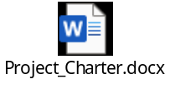

Statement of Work
Provides a description of the project and the current environment it will be affecting. Provides the goals, objectives, scope, project deliverables, timelines, period and location performance, terms and conditions for the vendor and client along with contact information.
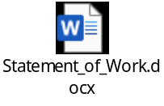

Milestones
Milestone | Description | Delivery Date
RMP | Requirements Management Plan | 2/6/2023
RTM 1.0 | Requirements Traceability Matrix 1.0 | 2/6/2023
PMP | Project Management Plan 1.0 | 2/6/2023
PPR 1.0 | Project Progress Report 1.0 | 2/13/2023
Demo #1 | Website Demo #1 Presentation  (50% complete) | 3/7/2023
RTM (Updated) | Requirements Traceability Matrix (Updated) | 4/3/2023
PPR 2.0 | Project Progress Report 2.0 | 4/3/2023
Demo #2 | Website Demo #2 Presentation  (75% complete) | 4/4/2023
Demo #3 | Final Demo - (Website 100% Complete) | 4/18/2023
PMP (Updated) | Final Project Management Plan | 4/28/2023
RTM (Updated) | Final Requirements Traceability Matrix | 4/28/2023
PPR 3.0 | Project Progress Report 3.0 | 4/28/2023

Stakeholder Register
Title | Name
Project Sponsor | J. David Chrisman
Business Owner | Kim Dehler
Administrators | Blue Ridge Animal Rescue Staff
Clients | Blue Ridge Animal Rescue Customers

Systems Architecture Diagram
Displays the system architecture software components used to implement the website as well as the relationships between the components.

Entity Relationship Diagram
This is a graphical representation of the entities, events/attributes, and the relationships between them contained within the website.
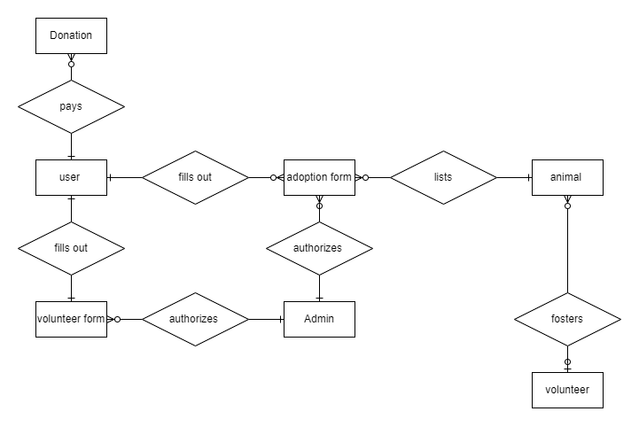

User Flow Diagram
This is a diagram used to visually display the flow of the website through all of its elements and helping to understand the customer experience.
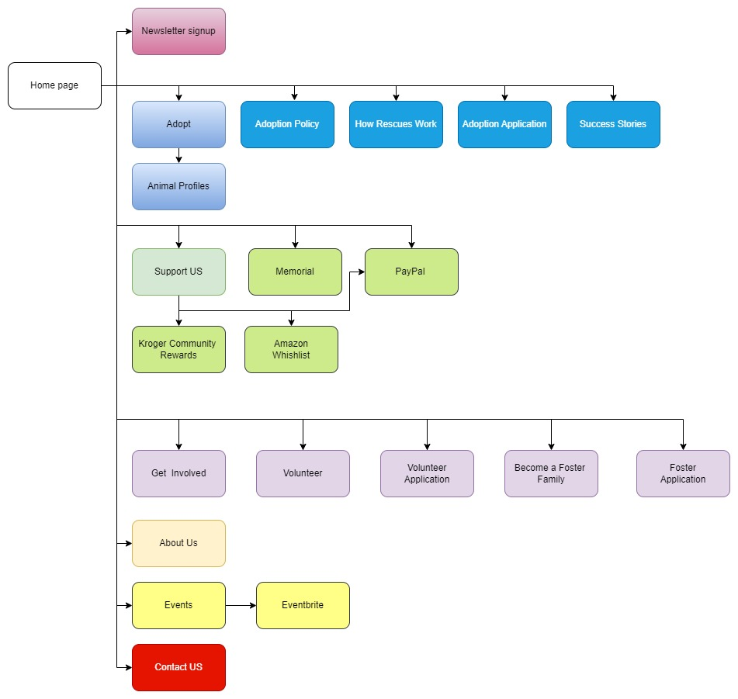

Work Breakdown Structure

Work Breakdown Structure Organized by Product
This is a hierarchical structure visually displaying the items that will be included in the website and how they are connected.

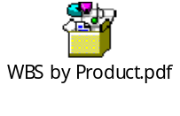

Work Breakdown Structure Organized by Phase
This is a diagram that shows the work breakdown structure organized by the website development phases.

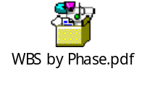

Work Breakdown Structure Dictionary
A document that describes detailed information about WBS items due to some tasks being vague. In order for people to know what to do, to estimate how long items will take, and what it will cost these vague items must be explained in more detail.

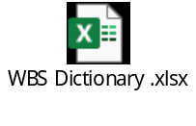

Requirements Management Plan
A document that describes the necessary information for our web development project requirements. It provides information about the responsibilities of the team and the tools that will be implemented in the team’s design process. This project will have many factors to establish the website for the company and the tools, people, and environment are all important criteria to document for this planning phase for the website.

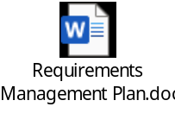

Requirements Traceability Matrix
A table used to assist the user in determining information about the requirements of the project including listing the requirement itself, the status, as well as the implementation, testing, and verification dates for each requirement.

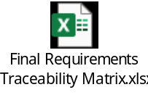

Project Progress Report
A document used to explain the progress that the team has made on the project along with the risks, issues, dependencies, and the next steps to be taken in the project.

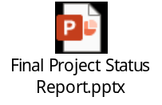

Communication Plan
Our primary form of communication will be through group texts on Discord. Email will also be used to communicate. SharePoint will be used to store and share our project documentation. Discord servers will also be used for quick sharing and review of completed work.
A preliminary team meeting will occur every Tuesday after class to create an agenda for the upcoming formal team meeting. The formal team meeting will be held every Thursday at 4:00 PM to assign and complete the tasks for the week. Virtual participation in the team meetings will be through Discord for any team member who is not able to attend in person. The meeting location shall be in the Business School room 008. Any time or location changes will be discussed and voted on with the hope to allow for full participation of all team members

Risk Plan
Any risk shall be communicated to all team members as soon as it is recognized. All team members will review the risk and develop solutions. These solutions will be presented and voted on by the team to resolve the issue as quickly and effectively as possible. All identified risk will be recorded in the Risk Log (section 3.2). The amount of risk that will be tolerated will be decided by how the issue will ultimately affect the success of the project and allow us to meet our requirements.
Various risks include but not limited to:
  - Budget – ballooning expenses
  - Time – failure to meet deadlines
  - Scope creep – ballooning requirements
  - Resources – are required resources available to meet project requirements

Project Plan

Schedule
A bar chart used as a project management tool to illustrate the work that is completed over a period of time. It displays the tasks to be completed and schedule bars on a timeline to visualize the work over time.

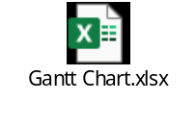

Assumptions
It is assumed that:
- The project will not change in scope.
- The resources identified will be available upon request.
- Approved funding will be available upon request.
- The project will be completed on time including each demo presentation.

Constraints
- The project must operate within the budget.
- The project must be completed by the end of semester deadline of April 28, 2023.
- The project team must deliver the software with no requirement for additional hardware.

Budget, Risks and Change Management

3.1 Project Budget

List of the task and how much the labor and materials are necessary to execute it will cost. Includes our budget and the actual amount spent in order to track planned costs against actual costs.

Item # | Task | Labor | Materials | Budget | Actual
1 | GoDaddy Wordpress Hosting (Basic) | $0 | $0 | $150.00 | $114.53
2 | Domain Name | $0 | $0 | $9.99 | $0
3 | SSL Certificate | $0 | $0 | $60.00 | $0
4 | Animal Wildlife Pro theme | $0 | $0 | $59.00 | $39.00

3.2 Risk Log

Identify risks to the project including the impact of the risk, the response taken to mitigate the risk, the level of risk and who on the team will own the response if the issue in fact arises.

ID | Risk | Impact | Response | Risk Level | Risk Owner
1 | Payment System | Threat of stolen monetary account information | Choose a trusted 3rd party payment system | Low | Ethan
2 | Website Access | Website Admin require secure login | WordPress/  GoDaddy have encrypted login | Low | Rob
3 | Outdated and unpatched website security | Increased threat of unauthorized access to website | Turn on automatic security updates and patches | Low | Kelechi
4 | Outdated or unused plugins | Increased threat of unauthorized access to website | Turn on automatic  updates and delete unused plugins | Low | Kelechi
5 | Stolen user information | Damage to website and customers | Secure a SSL certificate | Low | Ethan
6 | Threat from hackers and Malware | Stolen sensitive information and damage to the website | Jetlink plugin provides downtime monitoring and malware scanning | Low | Rob
7 | Website Shutdown | Lost business due to customers lack of access | GoDaddy is a trusted website host with a 24/7 helpline | Low | George
8 | Website not user-friendly | Lost business | Follow 3 click rule. Keep simple but informative | Low | Alexus
9 | Lack of storage capacity | Limitations to the website | GoDaddy has scalable plans to fit needs | Low | George

3.3 Change Management

Identifies when a change request is made, tracking its impact, response and whether the change control board has approved it or not.

Date Identified | Request | Impact | Approval | Date Started | Date Completed
2/9/2023 | Remove the store | Customers will no longer be able to buy merchandise | 2/9/2023 | 2/9/2023 | 2/9/2023
2/14/2023 | Make the animal adopt page the home page | Customers will immediately be shown the adoptable animals when visiting the website | 2/14/2023 | 2/14/2023 | 2/14/2023
2/21/2023 | Remove the animal adopt page as the homepage and return to the traditional homepage | 2/21/2023 | 2/21/2023 | 2/21/2023 | 2/21/2023
2/23/2023 | Use ShelterLuv to process donations | Information will be securely stored in the ShelterLuv database | 2/23/2023 | 2/23/2023 | N/A - was never able to set up ShelterLuv account
3/22/2023 | Change the template | Changes the look of the website, mainly the header and menu | 3/22/2023 | 3/22/2023 | 3/23/2023
3/22/2023 | Move all payment system data collection to the trusted 3rd party (PayPal) | Better secure sensitive customer data | 3/28/2023 | 3/30/2023 | 4/13/2023
3/23/2023 | Remove ShelterLuv as the database | We will no longer be using a database for this project. | 3/23/2023 | 3/23/2023 | 3/23/2023
3/23/2023 | Remove ShelterLuv for processing donations | Will have to find a new method to collect donations | 3/23/2023 | 3/23/2023 | 3/23/2023
3/28/2023 | Revamp the template of the homepage | We wanted to have a different look to the homepage | 3/28/2023 | 3/28/2023 | 3/28/2023
3/28/2023 | Create a separate Foster page | Separates the fostering from the other volunteer activities | 3/28/2023 | 3/28/2023 | 3/30/2023
4/6/2023 | Return to the traditional homepage that we started previously | The new homepage did not fit with the website. Returned to the previous version. | 4/6/2023 | 4/6/2023 | 4/6/2023

Appendix

Supplemental Artifact - Rough Project Schedule (listing many activities and tasks)

