Homework 1 - Networking Utilities
Note: Zoom in on the outputs.

Task 1
- Take a screenshot of the output.
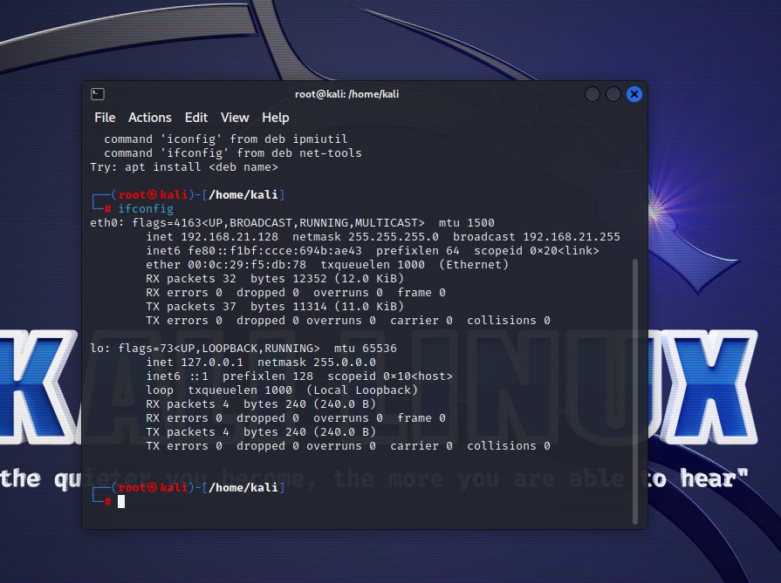

Task 2
- Take a screenshot of the output.
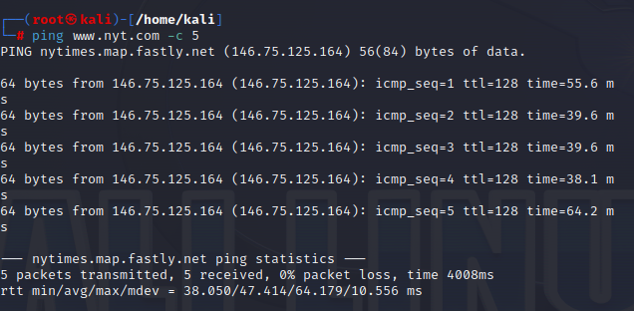

Task 3
- Take a screenshot of the output.
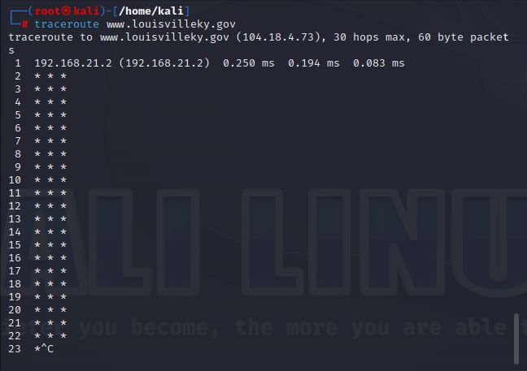

Task 4
- Take a screenshot of the output.
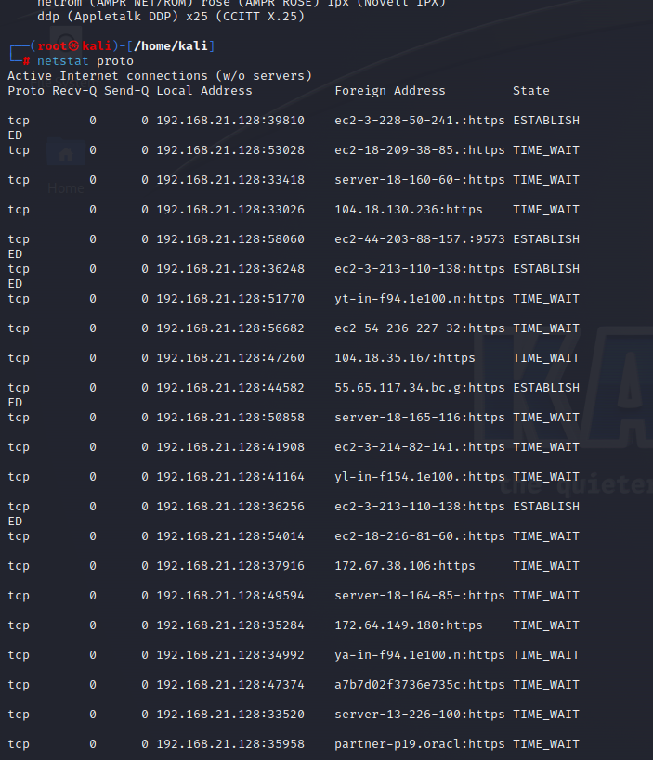

Task 5
- Take a screenshot of the output.
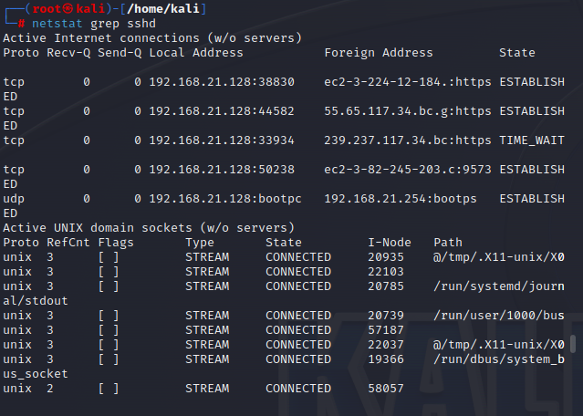

Task 6
- Take a screenshot of the output.
