Homework 2: Mastering the Basics of SQL Server

(Task 1: 5 points) Complete Task #2 through Task #4 while placing your sql files in Queries. Show in a screenshot that your Homework 2 project in Solution Explorer contains three sql files in Solution Explorer.
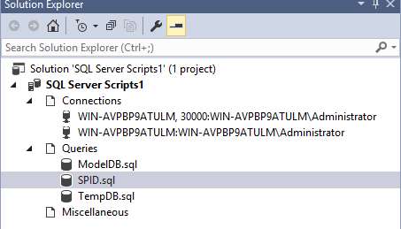

(Task 2: 5 points) Show in a screenshot that DatabaseLog_test table is created in MyDatabase2, and not in MyDatabase1.
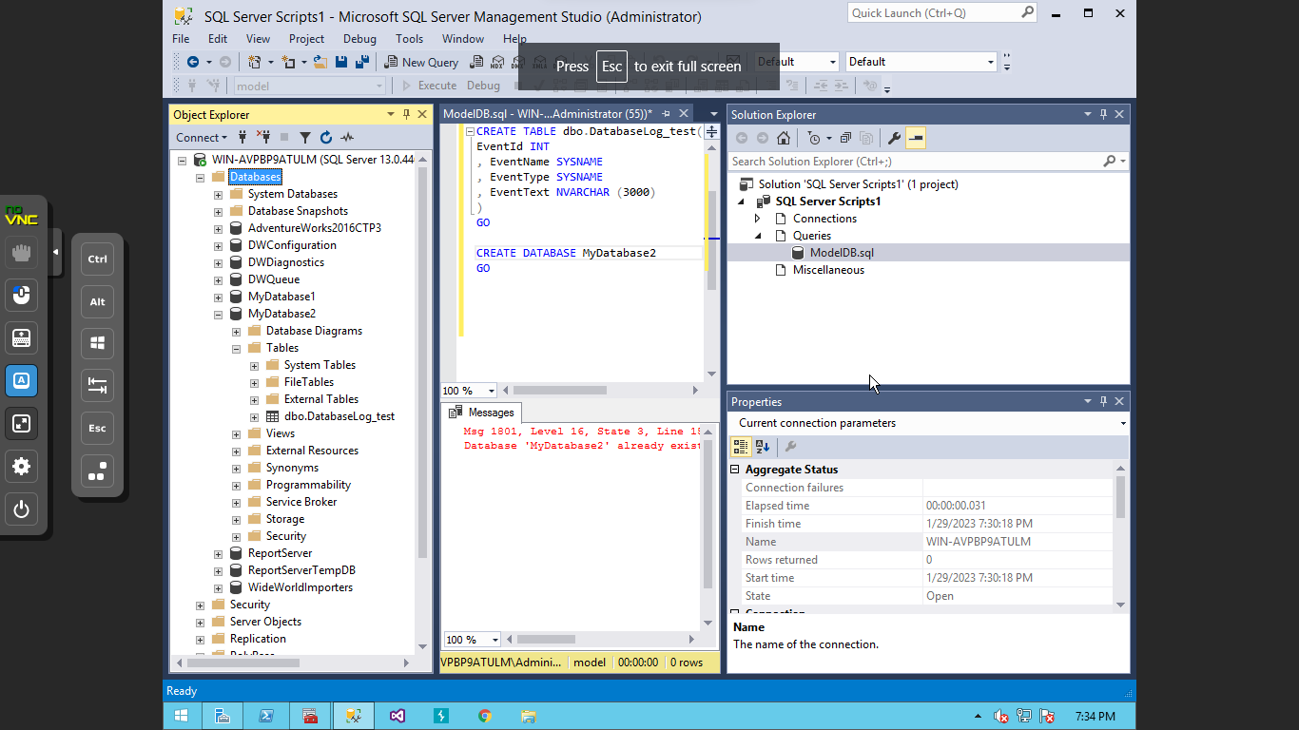

(Task 3: 4 points) Create the three temp tables listed above and show their existence using the SELECT command above. Attach a screenshot.
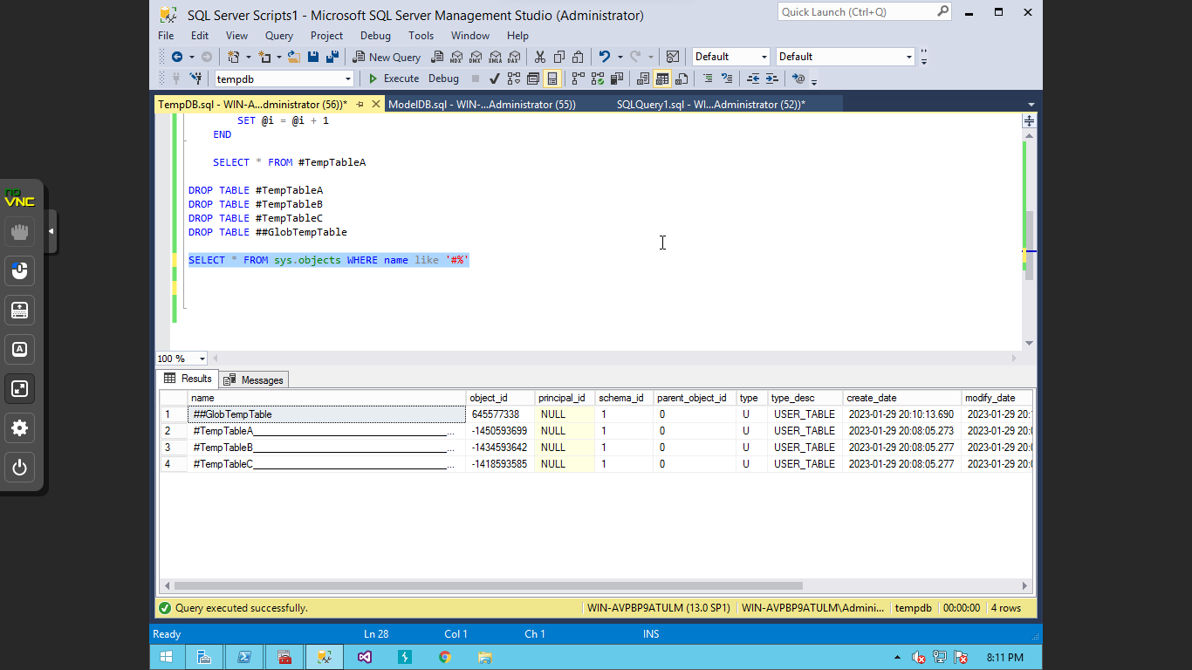
(Question: 1 points) When do we use temporary Tables? List two scenarios. When do we use table variable over temp table?
Temp tables would be better with larger amounts of data. Having a temp table will make it easier to go through and change. Another scenario where temporary tables are useful is when data needs to be stored and used later.
Overtime with variable lists, it makes it easier to use small amounts of data and make changes.

(Task 4: 5 points) Fill in all the blanks. Keep in mind that you have made a connection via a dynamic port not the default number. Your answers to the second column must be consistent with the connection you made.
 | Name/Number | Description (definition)
SPID | 55 | SPID is a session that is created when logged into the SQL server.
SID | 0x0105000000051500000007C98DB | The SID is the security ID that is associated with the principle when logging in.
principal_id | 259 | Login Identifier
net_library | TCP/IP | Network protocol used for the client and the server to communicate
local_tcp_port | 30000 | Our TCP port we used to connect

In addition, show the result of each of the four queries in a screenshot.
