Homework 6: User Management

Task 4. Assigning User Mappings to Fixed Database Roles

A. Assigning a user to a database role

B. Verifying the results
5) Does it fail? Show the result in a screenshot. Describe your observation and explain why it fails.
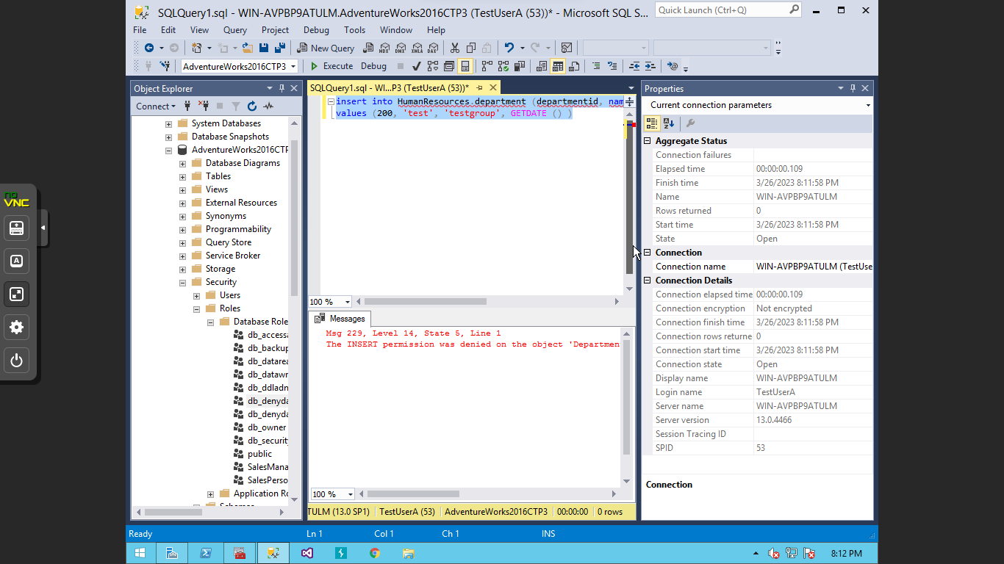

The query does fail because the “db_owner” in the user mapping of the security settings was unchecked. Denying the user from making any changes.

10) Does it fail? Show the result in a screenshot. Describe your observation and explain why it fails. 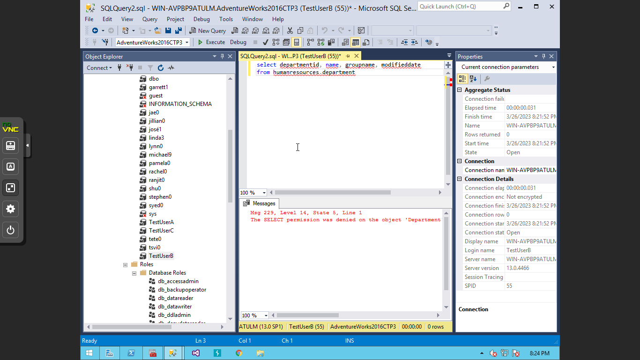

The reason that the query fails is that the user does not have permission to make changes within the database, and the default schema for TestUserB is “dbo”.

Task 5. Creating a Custom Database Role

A. Creating a custom database role

B. Verifying results
4) Does it work? Show the result in a screenshot. Describe your observation and explain why it works. 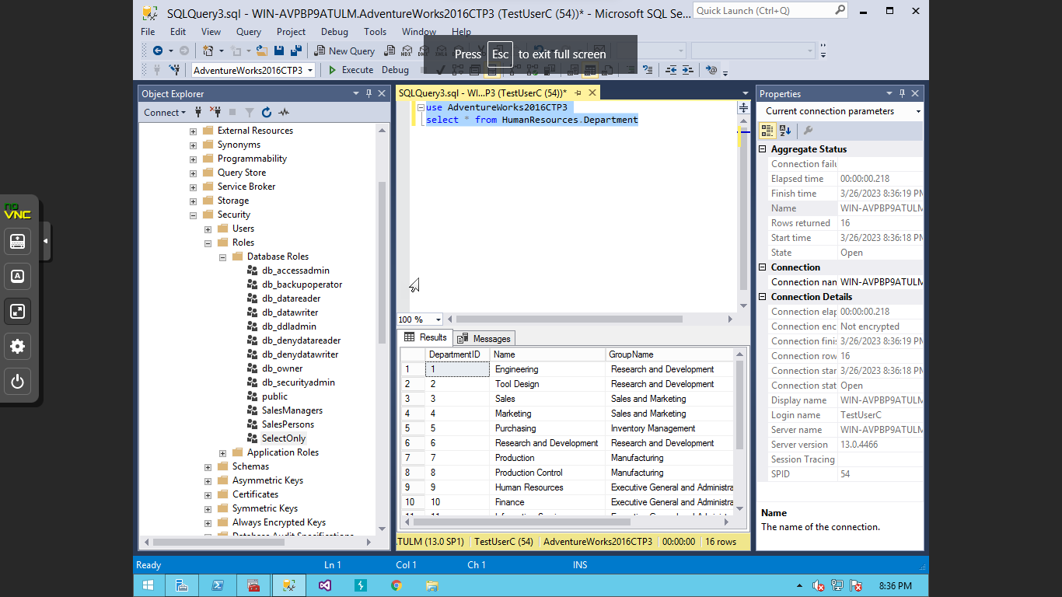

The query is able to run because the user has permissions to use, but only use select functions of the database.

5) Does it fail? Show the result in a screenshot. Describe your observation and explain why it fails. 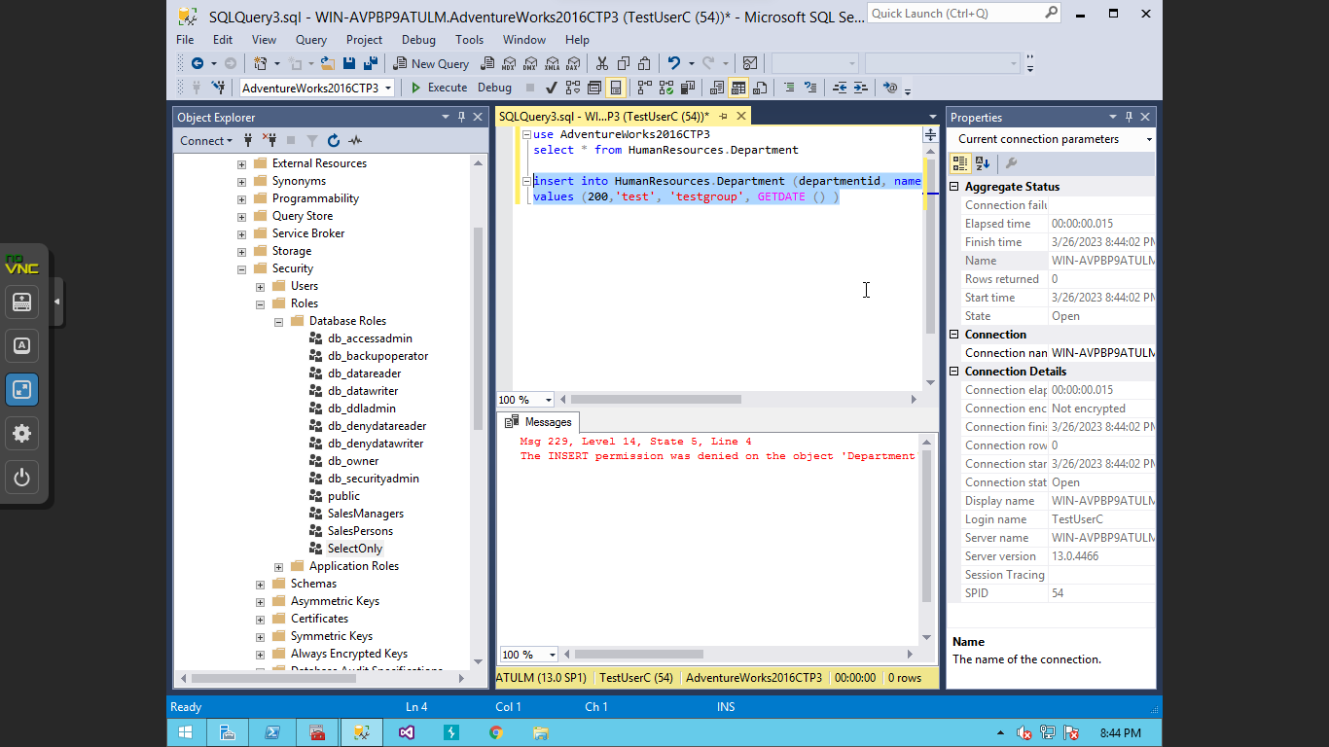

The reason that the query does not run is because the user only has permissions to select things within the database not insert or change any information.

Task 6. Creating an Application Role

A. Creating an Application Role

B. Verifying Results
2) Does it fail? Show the result in a screenshot. Describe your observation and explain why it fails.
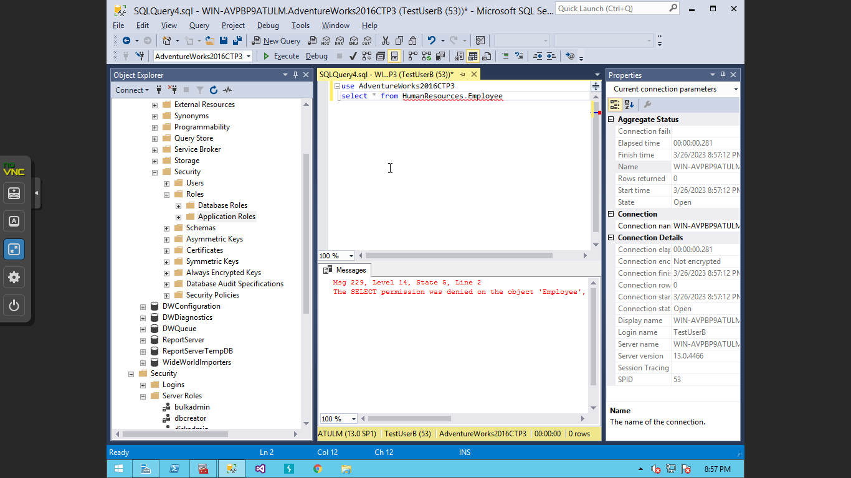

This query does not work because the user does not have permission to select information within the table.

4) Does it work? Show the result in a screenshot. You have to click on Results to view the results. Describe your observation and explain why it works.
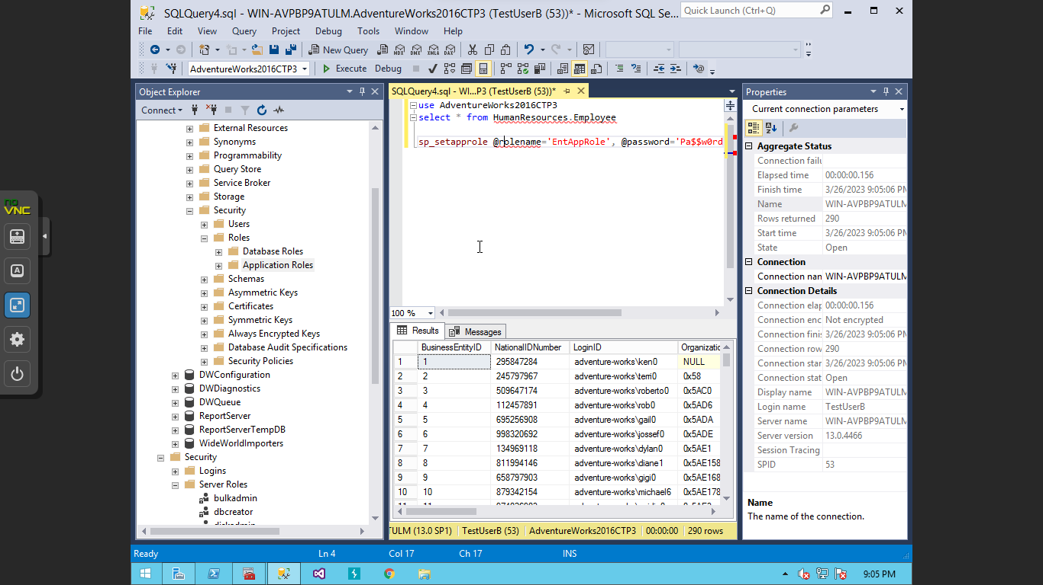

In the messages portion of the results it states that “ the current user account was invoked” this means that the permissions of the current user enabling them to select information from the table.

Task 7. Assigning Permissions
9) Does it work? Show the result in a screenshot. Describe your observation and explain why it works.
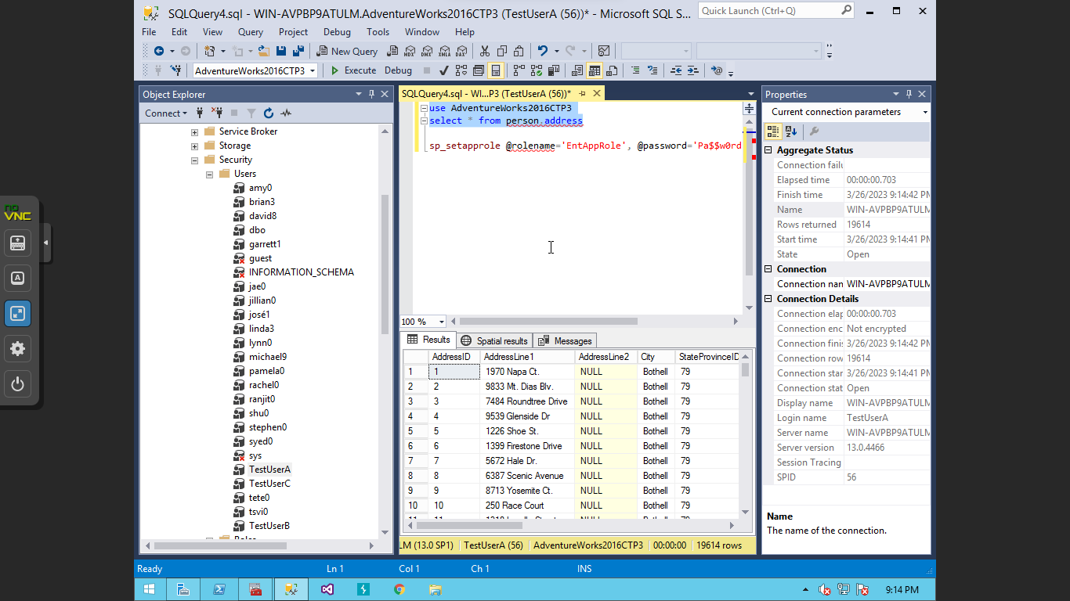

The query was able to run because the user has the permission to select information from that table.

13) Run the previous query. Show the result in a screenshot. Describe your observation and explain why it fails.

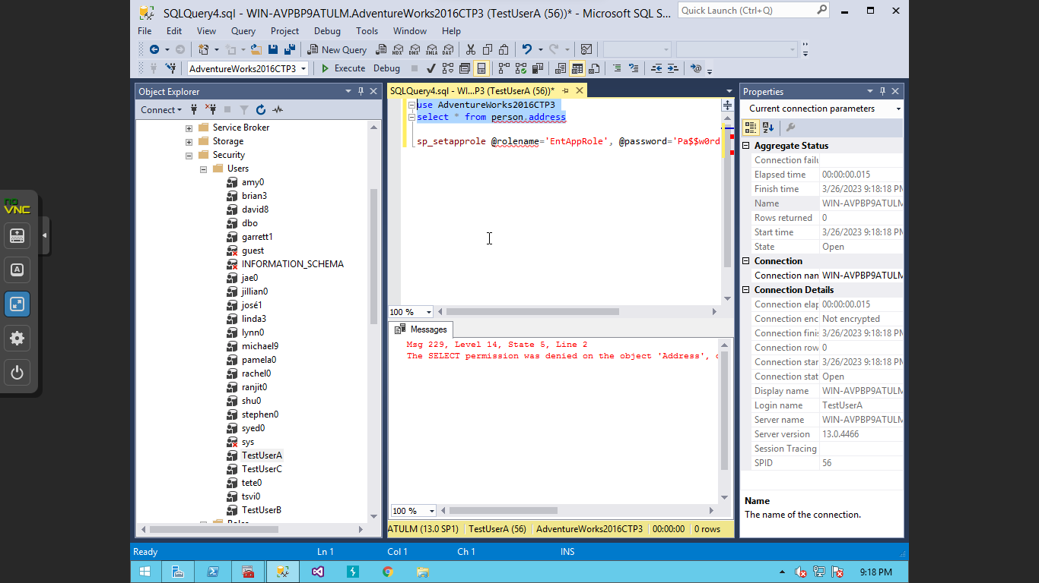
This query fails because the permissions that the user had to select information from the table has been removed.

15) Run the previous query. Show the result in a screenshot. Describe your observation and explain why it works.

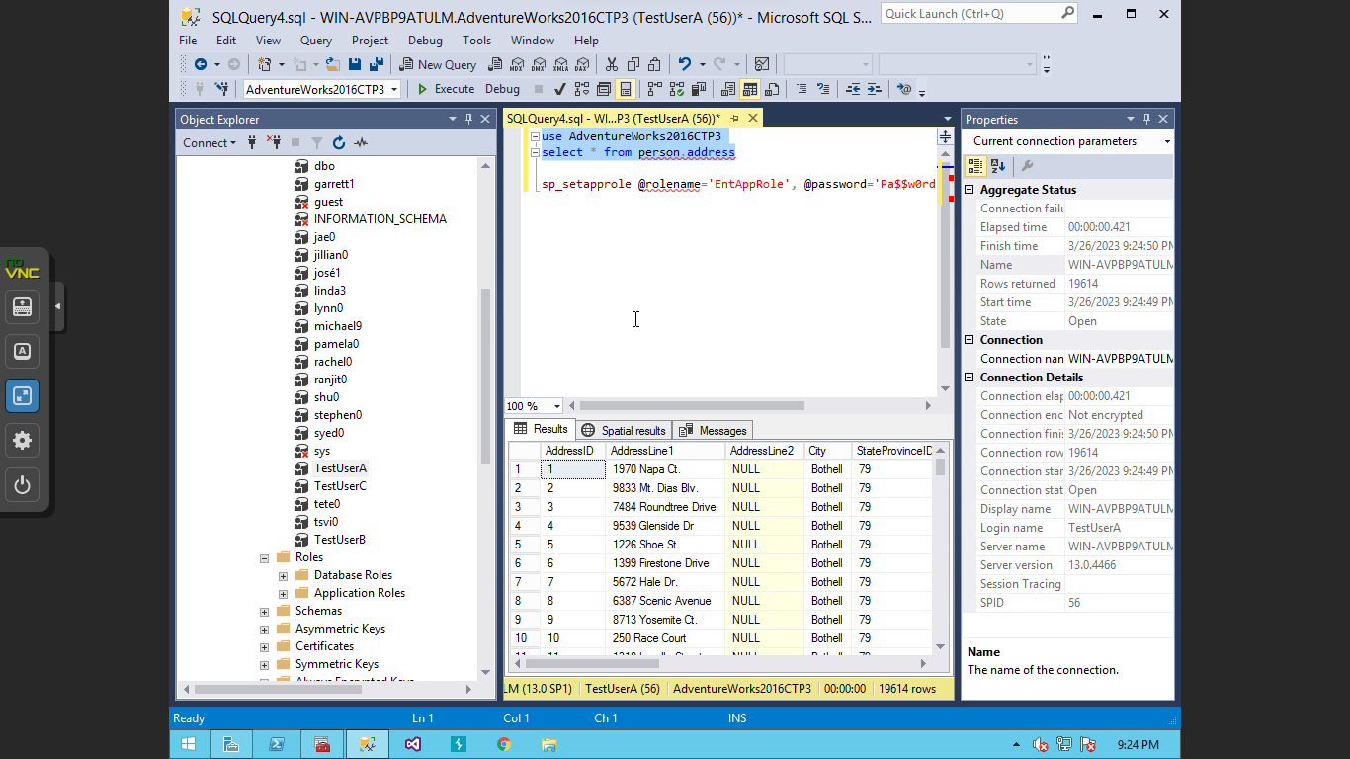

The query can be run because the permissions within the db_datareader allows the user to be able to read the data within the table.

19) Run the previous query. Show the result in a screenshot. Describe your observation and explain why it fails.

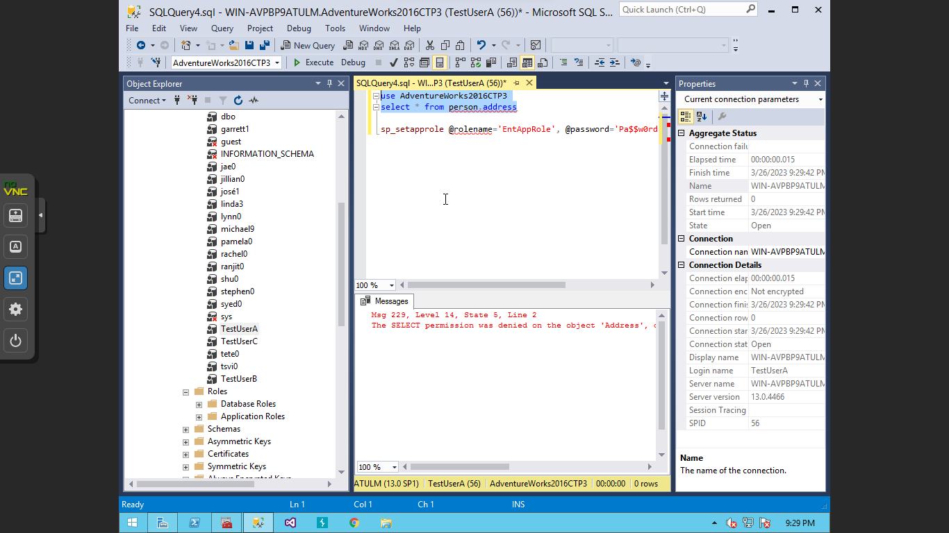

The query does not run because the user is not able to select the information due to being denied by permissions.

