Iteration 3
Blue Ridge Animal Rescue and Sanctuary

Scott Dinh, Dane Froelicher, Yen Hsieh Hsu, Jillian Offutt, Noah Ruiz, Ethan Troutman
College of Business, University of Louisville
CIS 320: Systems Analysis and Design
Dr. Zahra Hatami
November 5, 2022

Table of Contents

System Requirements 3
Use Cases 6
Trace Matrix 31
Use Case Diagram 32
Gantt Chart 42
Use Case Prototype 43

System Requirements
Below is a complete list of requirements needed for the website of Blue Ridge Animal Rescue and Sanctuary to function as per the client’s requirements. The requirements are ordered in a hierarchical way, separated into functional and non-functional requirements, and each with a unique ID. The requirements present should also be verifiable/testable and unambiguous.
Functional Requirements
Donation Requirements
ID: SR001 - The donation system will allow donors to register.
ID: SR002 - The donation’s payment system will accept major forms of payment by donors.
ID: SR003 - The donation’s payment system will allow for recurring/automatic monthly payments.
ID: SR004 - The donation’s payment system will allow donors to choose a predefined amount of donation.
ID: SR005 - The donation’s payment system will allow donors to input a custom amount of donation.
ID: SR006 - The donation system will allow donors to edit their account/profile.
ID: SR007 - The donation system will allow donors to delete/close their account/user profile.

Adoption Requirements
ID: SR008 - The adoption site will have a gallery of available pets to adopt.
ID: SR009 - The gallery will be able to redirect users to individual pages for the pet.
ID: SR010 - The adoption page will contain an option/button to redirect users to adoption application forms.
ID: SR011 - The adoption site will have application forms for users to fill out.
ID: SR012 - The adoption site will be able to register user information.
ID: SR013 - The adoption site will allow users to edit their application.
ID: SR014 - The adoption site will allow users to delete their application.
ID: SR015 - The adoption site will allow users to add a testimonial after a successful adoption.
ID: SR016 - The adoption site will allow users to edit their testimonial after a successful adoption.
ID: SR017 - The adoption site will allow users to remove their testimonial after a successful adoption.

Database Requirements
ID: SR018 - The database will allow the user to store information about the animals.
ID: SR019 - The database will allow forms to be stored.
ID: SR020 - The database will allow the user to edit information stored in the database.
ID: SR021 - The database will allow the user to retrieve the data.
ID: SR022 - The database will allow the user to delete information stored in the database.
ID: SR023 - The database will have the ability to associate database items.
ID: SR024 - The database will allow the user to download a copy of the stored information.
ID: SR025 - The database will have the ability to back up the stored information.
ID: SR026 - The database will allow the user to completely erase all information stored in the system.

Website’s Social Requirements
ID: SR027 - The website will allow users to sign up for email newsletters.
ID: SR028 - The website will allow users to be redirected to the client’s other social media pages.
ID: SR029 - A contact form will be created.
ID: SR030 - The contact form will be able to be submitted by users.
ID: SR031 - The filled contact form will be redirected to the client.
ID: SR032 - The website will allow users to unsubscribe/opt-out of newsletters.
ID: SR033 - The website will allow users to start applications for volunteering.
ID: SR034 - The website will allow users to delete their volunteer applications.
ID: SR035 - The website will allow administrators to create newsletters.
ID: SR036 - The website will allow administrators to edit newsletters.
ID: SR037 - The website will allow administrators to delete newsletters.
ID: SR038 - The website will allow administrators to create events.
ID: SR039 - The website will allow administrators to add events to an event calendar.
ID: SR040 - The website will allow administrators to edit events.
ID: SR041 - The website will allow administrators to delete events.
ID: SR042 - The website will allow users to add merchandise items into cart.
ID: SR043 - The website will allow users to purchase merchandise items.
ID: SR044 - A gallery of photos the client provides/uploads will be created.
ID: SR045 - The website will allow administrators to edit the gallery.
ID: SR046 - The website will allow administrators to delete specific content in the gallery.
ID: SR047 - A FAQ section will be created.
ID: SR048 - The FAQ section will be editable by the administrators.
ID: SR049 - The FAQ section will allow administrators to delete the section or content.

Non-Functional Requirements
Performance
ID: SR050 - The website will load quickly and smoothly, without much waiting time or lag.
ID: SR051 - The database will have the ability to function at a high operating speed, increasing data retrieval speed.

Security
ID: SR052 - The website will be secured (HTTPS).
ID: SR053 - The payment system will be secured by the third-party provider.
ID: SR054 - The website will have a backup.
ID: SR055 - The database will have a backup.
ID: SR056 - The systems will only be accessible by administrators.

Capacity
ID: SR057 - The database will have enough storage space for the information.

Accessibility/Simplicity
ID: SR058 - The website will be easily accessible online.
ID: SR059 - The website will be user-friendly.
ID: SR060 - The donation’s payment system will be easy for users to use.
ID: SR061 - The adoption application will be easy to fill out and submit.
ID: SR062 - Volunteer forms will be simple to fill out and submit.
ID: SR063 - The database will be simple for admins to use.

Availability
ID: SR064 - The website will be compatible with most web browsers.
ID: SR065 - The website will be available 27/7 with little downtime.
ID: SR066 - The payment system will provide payment support to users.
ID: SR067 - Database will be compatible with Windows operating system.

Use Cases

Use Case 1: Create Donation
Brief Description: This use case describes how the user makes a donation.
Primary Actors: Donors/User
Secondary Actor: None
Preconditions: A user must first fill out a donation form.
Main Flow:
- The use case starts when a user fills out a donation form.
- The user decides to create a donation by pressing the submit button.
Postconditions: Only users that fill out a form can make a donation.
Alternate Flows: None

Use Case 2: Edit Donation
Brief Description: This use case describes how to edit a donation created.
Primary Actors: Donors/User
Secondary Actor: None
Preconditions: A user must first fill out a donation form.
Main Flow:
- The use case starts when a user fills out a donation form.
- The user decides to edit the form by pressing the edit button.
Postconditions:
- Only users that fill out a donation form can edit one.
- Only users that haven’t submitted the form can edit their donation.
Alternate Flows: None

Use Case 3: Delete Donation
Brief Description: This use case describes how a user can delete their donation.
Primary Actors: Donors/User
Secondary Actor: None
Preconditions: A user must first fill out a donation form.
Main Flow:
- The use case starts when a user fills out a donation form.
- The user decides to delete the form by pressing the delete button.
Postconditions: Only users that fill out a donation form can delete one.
Alternate Flows: None

Use Case 4: Create new Donor
Brief Description: This use case describes how the user creates a donor account in order to make a donation.
Primary Actors: Donors/User
Secondary Actor: None
Preconditions: A user must first fill out a new Donor profile.
Main Flow:
- The use case starts when a user fills out a new donor profile.
- The user decides to create the new donor profile by pressing the submit button.
Postconditions: Only users that fill out a new donor profile can create a new donor account.
Alternate Flows: None

Use Case 5: Edit Donor Information
Brief Description: This use case describes how to edit the donor’s personal information on the donor’s account.
Primary Actors: Donors/User
Secondary Actor: None
Preconditions: A user must first fill out a new donor profile.
Main Flow:
- The use case starts when a user fills out a new donor profile.
- The user decides to delete the profile by pressing the edit button.
Postconditions: Only users that fill out a new user profile can edit one.
Alternate Flows: None

Use Case 6: Edit Payment Information
Brief Description: This use case describes how the donor can edit payment information.
Primary Actors: Donors/User
Secondary Actor: None
Preconditions: A user must first fill out a donation form.
Main Flow:
- The use case starts when a user fills out a donation form.
- The user inputs payment information into the donation form.
- The user decides to edit payment information when the user presses the edit button.
Postconditions: Only users that fill out a donation form and input payment information can edit their information.
Alternate Flows: None

Use Case 7: Delete donor
Brief Description: The donor can delete their account or an administrator can remove donor profile
Primary Actors: Donor, administrators
Secondary Actors: Administrators
Preconditions: A donor account exists
Main Flow:
- Donor logs into account
- Donor deletes account
- Donor confirms account deletion
- Administrators confirm account deletion
Postcondition: The formerly existing donor account no longer exists
Alternate flow:
- Admin logs into administrator account
- Admin deletes account
- Admin confirms account deletion

Use Case 8: Add pet information
Brief Description: Administrator or volunteer adds pet information onto website for potential adoptees
Primary Actors: Administrators, volunteers
Secondary Actors: None
Preconditions: A pet is not listed on the website but is under Blue Ridge’s custody
Main Flow:
- Admin adds information about the pet
- Admin adds this information into database
Postcondition: There is information about a new pet added onto the website
Alternate flow:
- Volunteer adds information about the pet
- Volunteer adds this information into database

Use Case 9: Add pet photos
Brief Description: Administrator or volunteer adds pet photos onto website for potential adoptees
Primary Actors: Administrators, volunteers
Secondary Actors:
Preconditions: A pet exists on the website and database, but has no pictures
Main Flow:
- Admin adds pet photos
- Admin adds photos into database
Postcondition: There are new pictures of a new pet added onto the website
Alternate flow:
- Volunteer adds pet photos
- Volunteer adds photos into database

Use Case 10: Edit pet info or photos
Brief Description: Administrator or volunteer edits existing pet photos or information
Primary Actors: Administrators, volunteers
Secondary Actors: None
Preconditions: A pet exists on the website and database, but has information that needs to be changed
Main Flow:
- Admin goes to existing pet’s profile
- Admin removes incorrect or old information/pictures and replaces it with new info/pictures
- Admin confirms changes
Postcondition: Pet’s information or photos are edited
Main Flow:
- Admin goes to existing pet’s profile
- Admin removes incorrect or old information/pictures and replaces it with new info/pictures
- Admin confirms changes

Use Case 11: Go to adoption page
Brief Description: Adopter clicks link in pet information and goes to the adoption page
Primary Actors:
Secondary Actors: Administrators
Preconditions: An adopter wants to adopt an eligible pet
Main Flow:
- Adopter goes to a pet’s information page
- Adopter clicks the link to go to the adoption page
- Admins confirm eligibility
Postcondition: Adopter is taken to the adoption page
Alternate flow:
None

Use Case 12: Go to forms from adoption page
Brief Description: Adoption page links to forms required for adoption
Primary Actors:
Secondary Actors: Administrators
Preconditions: An adopter wants to adopt an eligible pet
Main Flow:
- Adopter goes from the adoption page to the forms
- Admins confirm eligibility
Postcondition: Adopter fills out forms
Alternate flow:
None

Use Case 13: Fill out forms
Brief Description: Adopters fill out forms required for adoption
Primary Actors: Adopter
Secondary Actors: Administrators
Preconditions: An adopter knows all of the require information
Main Flow:
- Adopter goes from the adoption page to the forms
- Adopter fills out forms with correct information
- Admins confirm eligibility
Postcondition: Adopter fills out forms
Alternate flow:
None

Use Case 14: Edit applications
Brief Description: Adopters or administrators can edit application if they need to update information or correct misinformation
Primary Actors: Adopter
Secondary Actors: Administrators
Preconditions: An adopter needs to change some information on the adoption forms
Main Flow:
- Adopter logs in
- Adopter goes to application and clicks edit
- Adopter edits information and confirms
- Administrators confirm
Postcondition: Adopter information is updated
Alternate flow:
None

Use Case 15: Delete application
Brief Description: When a user fills out an adoption application they have the option to delete it.
Primary Actors: Adopters/User
Secondary Actor: None
Preconditions: A user must first fill out an adoption application.
Main Flow:
- The use case starts when a user fills out an adoption application.
- The user decides to delete the application by pressing the delete button.
Postconditions: Only users that fill out an application can delete one.
Alternate Flows: None

Use Case 16: Create Testimonial
Brief Description: A donor can create a testimonial for Blue Ridge Animal Sanctuary based on the experience they've had.
Primary Actors: Donors/Users
Secondary Actor: None
Preconditions: A user must first donate to Blue Ridge in order to fill out a testimonial.
Main Flow:
1.The use case starts when a user donates to Blue Ridge.
2.The user decides whether to create a testimony.
3. If yes, the user creates testimony and submits it.
Postconditions: Only users that have donated can create a testimonial.
Alternate Flows:
- User decides not to create a testimonial after donating.
- Main flow then becomes Null.

Use Case 17: Edit Testimonial
Brief Description: Donors can edit an existing testimonial after creating one.
Primary Actors: Donors/Users
Secondary Actor: None
Preconditions: A user must first create a testimonial.
Main Flow:
1. User creates a testimonial.
2.. User then decides to edit their testimonial

Postconditions: Only users that have created a testimonial in order to edit one.
Alternate Flows: None

Use Case 18: Delete Testimonial
Brief Description: The donor or Administrator can delete an existing testimonial.
Primary Actors: Donors/User
Secondary Actor:Administrators
Preconditions: The user must first create and submit a testimonial.
Main Flow:
- The user creates a testimonial.
- The user must edit a testimonial.
- The user must submit a testimonial.
- The user has the option to delete an existing testimonial.
Postconditions: Only users that have created and submitted a testimonial can delete one.
Alternate Flows:
- The user creates a testimonial.
- The user must edit a testimonial.
- The user must submit a testimonial.
- The Administrator reviews the testimonial.
- The Administrator deletes the testimonial.

Use Case 19: Animal Forms database
Brief Description: The Admin creates a database that stores all animal information.
Primary Actors: Administrator
Secondary Actor: None
Preconditions: An animal must be picked up, or given to Blue Ridge.
Main Flow:
- Animal is picked up by Blue Ridge staff.
- Animals are added into the database with name and adoption prep status.
Postconditions: Only animals that are considered a part of Blue Ridge inventory can be put into the database.
Alternate Flows: None

Use Case 20: Adoption form database
Brief Description: The Admin creates a database that stores all adoption forms in all stages from current to previous adoptions.
Primary Actors: Administrator
Secondary Actor: None
Preconditions: An animal must be processed and ready for adoption.
Main Flow:
- Animals are processed for adoption.
- Administrator adds animal to adoption form database.
- Administrator adds animals to the appropriate section based on adoption status.
Postconditions: Only animals that are considered a part of Blue Ridge inventory, and are processed for adoption.
Alternate Flows: None

Use Case 21: Database Editing
Brief Description: The Admin can edit the database based on adoption status or updated animal information.
Primary Actors: Administrator
Secondary Actor: None
Preconditions: An animal must be placed in a database in order for a status change, or update information.
Main Flow:
- Animals are entered into the database.
- Admin updates animal information.
Postconditions: Only animals that are considered a part of Blue Ridge and entered into the database can be edited.
Alternate Flows:
- Animals are entered into the database.
- Admin changes adoption status.

Use Case 22: Retrieving Data
Brief Description: The Admin can retrieve an animal's information, and/or adoption status.
Primary Actors: Administrator
Secondary Actor: None
Preconditions: An animal must be placed in a database in order to retrieve information, or adoption status.
Main Flow:
- Animals are entered into the database.
- Animals information is updated.
- Animals information is retrieved from the database.
Postconditions: Only animals that are considered a part of Blue Ridge and entered into the database can have their information or adoption status retrieved.
Alternate Flows:
- Animals adoption status entered into the database.
- Animals adoption status is updated.
- Animal adoption status is retrieved.

Use Case 23: Linking Database Items
Brief Description: The Admin can associate certain database items pertaining to the animals
Primary Actors: Administrator
Secondary Actor: None
Preconditions: An animal must be placed in a database in order to link any common factors
Main Flow:
- Animal is entered in database
- Animal Information is taken
Postconditions:
- Only animals that are considered a part of Blue Ridge and entered into the database can have their information linked to any part of the database
Alternate Flows: None

Use Case 24: Backing Up Database
Brief Description: The Admin can store backups of the database in the cloud.
Primary Actors: Administrator
Secondary Actor: None
Preconditions: Admin must have access to cloud service.
Main Flow:
- Admin access database on software mainframe
- Admin converts database files to upload to cloud service
Postconditions:
- Only Admin that can access all of database can back it up
Alternate Flows: None

Use Case 25: Deleting Database
Brief Description: Admins have ability to delete any and all information stored on the database
Primary Actors: Administrator
Secondary Actor: None
Preconditions: Admin must have access to database software
Main Flow:
- Admin access database on software mainframe
- Admin selects certain irrelevant information to delete
- Admin deletes information from database
Postconditions:
- Only Admin that can access all of database can delete information
Alternate Flows: None

Use Case 26: Signing up for Newsletters
Brief Description: Users can sign in via email to receive BRARS Newsletters
Primary Actors: User
Secondary Actor: Admins
Preconditions: Users must have email or account stored in database
Main Flow:
- User must make account that has email linked
- User selects option to receive newsletters
- User receives newsletter via email
Postconditions:
- Only users with stored email will receive newsletters
Alternate Flows:
- User gives email to admin
- Admin adds email to database
- User receives newsletter via email

Use Case 27: Editing Newsletters
Brief Description: Admins can edit information pertaining to the newsletters or email information of the user
Primary Actors: Admin
Secondary Actor: None
Preconditions: Admin must have access to Newsletter creation/ editing platform, and user email database
Main Flow:
- Admin accesses platform for editing
- Admin edits/ updates user information
- Admin edits/ updates newsletter information
Postconditions:
- Updates must be reviewed and verified before sent out
Alternate Flows: None

Use Case 28: Opting out of Newsletters
Brief Description: Users can opt out of newsletters at any time
Primary Actors: User
Secondary Actor: none
Preconditions: Users must have email or account stored in database
Main Flow:
- User signs into account via email
- User selects to opt out of newsletters
Postconditions:
- Only users with stored email can opt out of newsletters
Alternate Flows: None

Use Case 29: Linking Social Media Accounts
Brief Description: Users can take link to BRARS social media accounts through their website
Primary Actors: User
Secondary Actor: Admins
Preconditions: Admin must have socials linked to webpage
Main Flow:
- User accesses BRARS webpage
- User clicks link to access BRARS social media accounts
Postconditions: User must have specific social media account to access BRARS account
Alternate Flows:
- User accesses BRARS social media directly from the same platform

Use Case 30: Creating Contact Forms
Brief Description: Users can create contact forms to contact Blue Ridge for any need
Primary Actors: User
Secondary Actor: Admins
Preconditions: Users must have at least one source of Blue Ridge contact information
Main Flow:
- User accesses form containing contact information for Blue Ridge
- User selects specific contact information to use
- User contacts Blue Ridge
Postconditions: None
Alternate Flows:
- User accesses Blue Ridge webpage
- User selects either phone number or email at the bottom of page
- User makes contact to Blue Ridge

Use Case 31: Respond Contact Form
Brief Description: Admins can receive communication from users through contact form filled out by users and respond to it.
Primary Actors: Admins
Secondary Actor: None
Preconditions: A user must first fill out a contact form.
Main Flow:
- The use case starts when an admin receives the contact form from a user.
- The admin responds to the contact form.
Postconditions: None
Alternate Flows: None

Use Case 32: Create Newsletters
Brief Description: Admins can create newsletters for the website and write email newsletters to send out to users via email.
Primary Actors: Admins
Secondary Actor: None
Preconditions: A database with user emails that signed up for newsletters must exist.
Main Flow:
- The use case starts when the admin creates a newsletter.
- The admin sends out the newsletter.
Postconditions: None
Alternate Flows: None

Use Case 33: Send Out Newsletters
Brief Description: Admins can send out the newsletters to users via email.
Primary Actors: Admins
Secondary Actor: None
Preconditions: A newsletter must already exist and a database of users who signed up for newsletters must exist.
Main Flow:
- The admin creates a newsletter.
- The admin sends out the newsletter to users who signed up for it.
Postconditions: None
Alternate Flows: None

Use Case 34: Delete Newsletters
Brief Description: Admins can delete an existing newsletter on the website.
Primary Actors: Admins
Secondary Actor: None
Preconditions: A newsletter must already exist.
Main Flow:
- The admin has created a newsletter.
- The admin has posted a newsletter on the website.
- The admin deletes an unwanted or incorrect newsletter.
Postconditions: None
Alternate Flows: None

Use Case 35: Create Event
Brief Description: Admins can receive communication from users through contact form filled out by users.
Primary Actors: Admins
Secondary Actor: None
Preconditions: None
Main Flow:
- The admins create an event.
- The admins add the event to the website calendar.
Postconditions: None
Alternate Flows: None

Use Case 36: Edit Event
Brief Description: Admins can receive communication from users through contact form filled out by users.
Primary Actors: Admins
Secondary Actor: None
Preconditions: An event must already exist.
Main Flow:
- The event is posted on the website calendar.
- Admins make changes to the event.
Postconditions: None
Alternate Flows: None

Use Case 37: Delete Event
Brief Description: Admins can receive communication from users through contact form filled out by users.
Primary Actors: Admins
Secondary Actor: None
Preconditions: An event must already exist.
Main Flow:
- The admins posted an event on the website calendar.
- The admins decide to delete the event from the website.
Postconditions: None
Alternate Flows: None

Use Case 38: Add merchandise to cart
Brief Description: Users of the website can add merchandise items listed out to their cart.
Primary Actors: Users
Secondary Actor: None
Preconditions: A merchandise store must exist.
Main Flow:
- The user browses through the merchandise webpage.
- The user adds items they want to purchase to their carts.
Postconditions: None
Alternate Flows: None

Use Case 39: Users can pay for merchandise
Brief Description: Users of the website can purchase merchandise items listed in their cart.
Primary Actors: Users
Secondary Actors: None
Preconditions: User must have items to purchase
Main Flow:
- The user adds their credit card number to the website.
- The user confirms the order and completes the purchase.
Postconditions: None
Alternate Flows: None

Use Case 40: Gallery of photos will be created
Brief Description: Once a gallery is created, Users and admins will be able to add photos.
Primary Actors: Users
Secondary Actors: Admins
Preconditions: Must have photos to add into the gallery.
Main flow:
- Must learn the proper steps to create a gallery.
- Share with the Users and Admins where the gallery can be found.
Postconditions: None
Alternate Flows: None

Use Case 41: Edit Gallery
Brief Description: Admins can delete photos.
Primary Actors: Admins
Secondary Actors: None
Preconditions: Gallery must be created.
Main Flow:
- There must be unwanted pictures added into the gallery.
- Admins can use their privilege to delete photos.
Postconditions: None
Alternate Flows: None

Use Case 42: Creation of a FAQ section
Brief Description: A FAQ allows visitors to ask questions.
Primary Actors: Visitors
Secondary Actors: None
Preconditions: There must be questions to be asked.
Main Flow:
- Design a FAQ that is easily accessible for visitors.
- Have a fast reply service to answer the questions.
Postconditions: None
Alternate Flows: None

Use Case 43: Edit FAQ Section
Brief Description: Admins can edit the FAQ Section.
Primary Actors: Admins
Secondary Actors: None
Preconditions: Creation of the FAQ Section.
Main Flow:
- Any mistake or possible changed items on the website.
- Admins are able to fix what needs to be changed.
Postconditions: None
Alternate Flows: None

Use Case 44: Delete FAQ
Brief Description: Anything written inside the FAQ can be deleted.
Primary Actors: Administrators
Secondary Actors: None
Preconditions: NSFW content or wrong answers sent in the FAQ.
Main Flow:
- Someone must type something inappropriate or incorrect.
- Administrators can catch the error and delete it off the page.
Postconditions: None
Alternate Flows: None

Use Case 45: Volunteers can apply
Brief Description: Visitors can apply on the website to volunteer.
Primary Actors: Volunteers
Secondary Actors: None
Preconditions: People need to have an interest sparked in the company to want to apply.
Main Flow:
- Easy accessible volunteer sign-up page.
- Visitors with enough interest to sign-up to volunteer.
Postconditions: None
Alternate Flows: None

Use Case 46: Delete Volunteer Applications
Brief Description: Admins and volunteers are able to delete other volunteer applications.
Primary Actors: Admins
Secondary Actors: Volunteers
Preconditions: The deleted volunteer had to be messed up.
Main Flow:
- The volunteer could do something that the staff doesn’t like.
- Admins are able to delete the application from there.
Postconditions: None
Alternate Flows: None

Trace Matrix
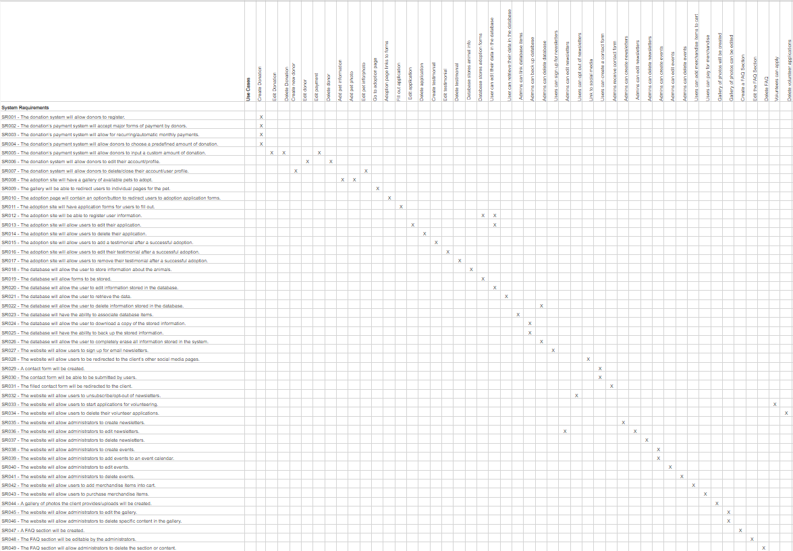

Use Case Diagram

Use Case 1, Use Case 2, Use Case 3:
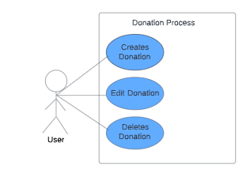
For the diagram, users have the ability to create (or start) a donation, edit his or her donation, or delete his or her donation amount.

Use Case 4, Use Case 5, Use Case 7:

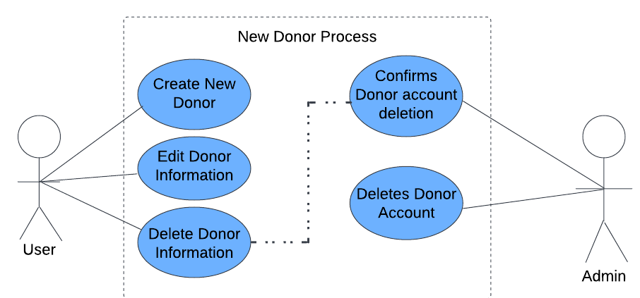

For the diagram of use cases 4,5, and 7, users are able to create new donor information such as creating their own accounts with personal/profile information, edit such information, or delete the information or account. Once the admin or system receives a request for account deletion, they proceed with relevant steps.

Use Case 6:
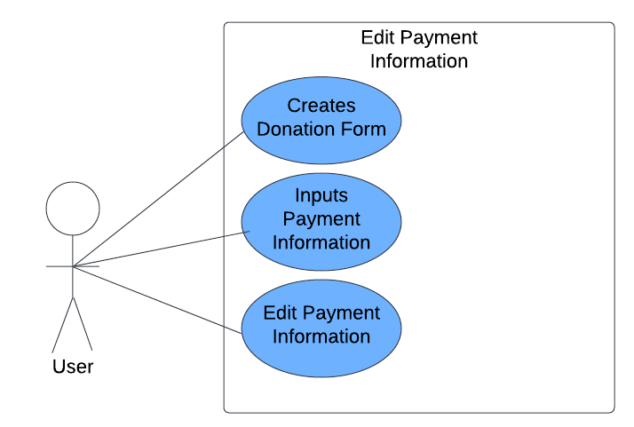
The diagram, following the initial diagram of use cases 1, 2, and 3, shows that the user can start the donation through creating and filling out the donation form, and inputting their payment information in the required places. Users are also allowed to edit their payment information, such as using another payment method.

Use Case 8, Use Case 9, Use Case 10:
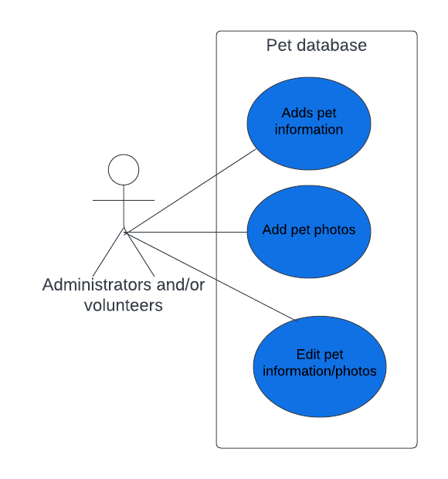
For this one it is simply displaying that admins are able to add information/photos about the pets, and edit the information in the pet database.
Use Case 11, Use Case 12, Use Case 13, Use Case 14, Use Case 15:
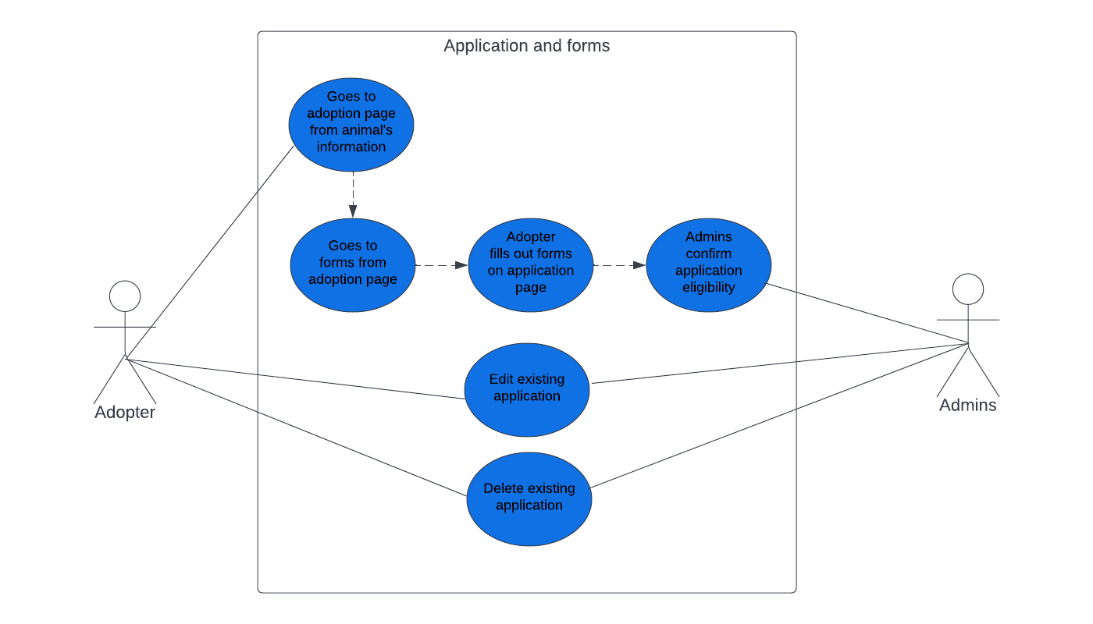
This diagram shows the process in which application and forms are made and relayed from a user to the administrator.

Use Case 16, Use Case 17, Use Case 18:
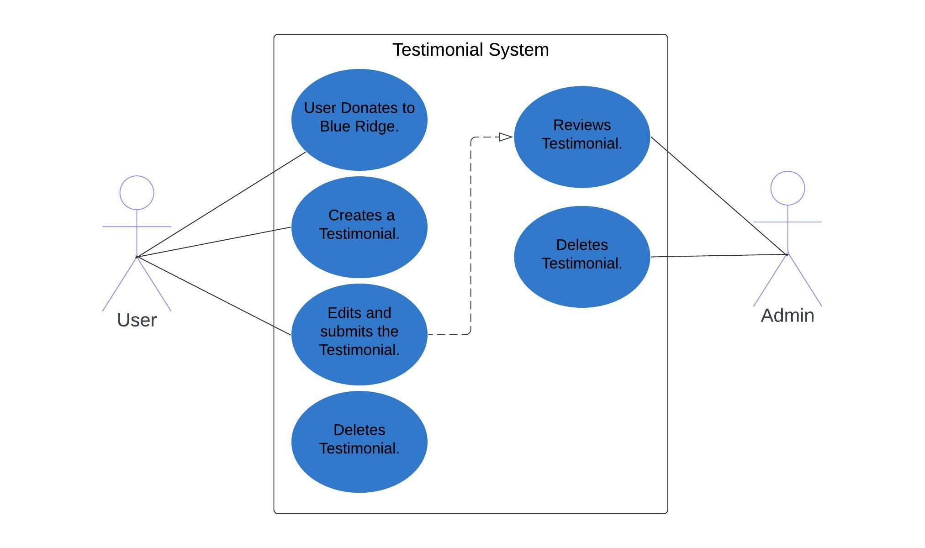
The above diagram shows how the feedback/testimonial system works, where a user, after completing specific actions such as a donation, can create a testimonial, where the user is allowed to edit or delete their own testimonial. Admins would receive the testimonial, and if approved, would be shown in the website.

Use Case 19, Use Case 20, Use Case 21, Use Case 22:
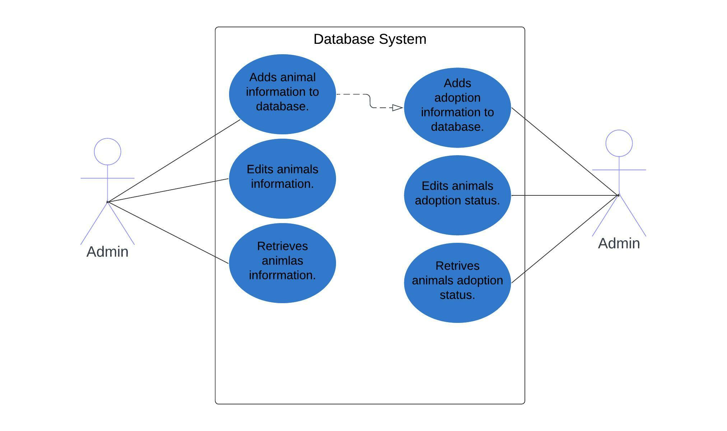
For the database system, the admins are able to add information, edit information, and retrieve information of the animals.

Use Case 23, Use Case 24, Use Case 25:
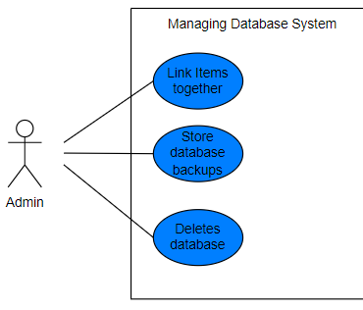
For the database system, the admin will also be able to link one record or item within the database to another, store backups of the database, and delete the database entirely is necessary.

Use Case 26, Use Case 27, Use case 28:
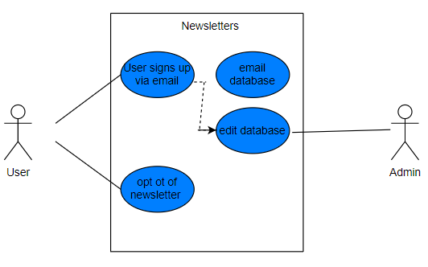
For the newsletters, users are able to choose between signing up or opting out of the newsletter. For admins, they can edit the emails stored in the database.

Use Case 29, Use Case 30:
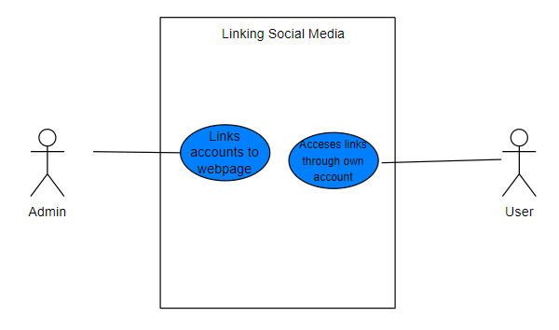
For this diagram, admins are able to link their social media pages to the icons on the webpage. Users that clicks on the icons are able to be redirected to the social media page.

Use Case 31:
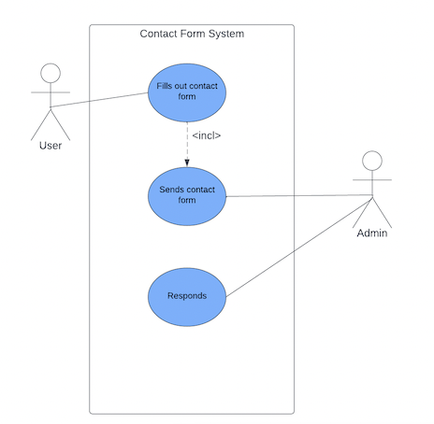
The diagram above shows that users are able to fill out contact forms, send in the contact form, and then the admins that receive the message are able to respond to it.

Use Case 32, Use Case 33, Use Case 34:
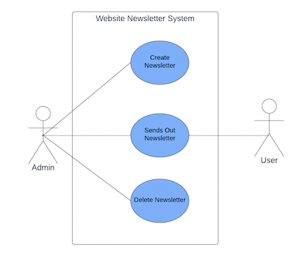
This diagram shows how the newsletter works from the side of the administrator, where the newsletter can be created and sent out to the users, or it can also be deleted.

Use Case 35, Use Case 36, Use Case 37:
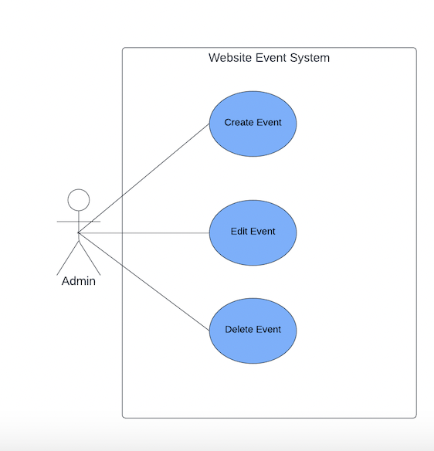
For the diagram above, it shows that administrators are able to create events to add to the calendar, edit events, and delete events.

Use Case 38, Use Case 39:
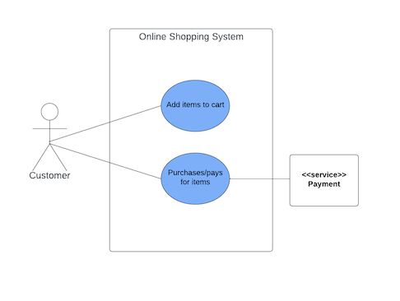
The diagram shows that in the case there is a merchandise store, users/customers are able to browse through items, add them into the cart, and purchase the items where the payment will be processed through a payment system service.

Use Case 40 and Use Case 41:
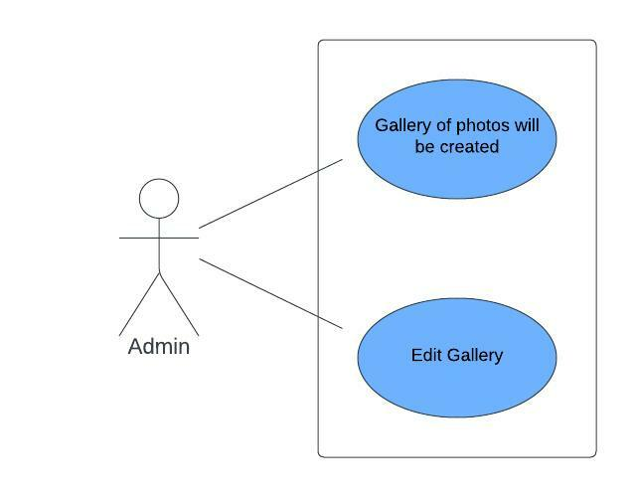
This diagram shows that administrators are able to create a gallery of photos for the website, and edit the gallery.

Use Case 42, Use Case 43, and Use Case 44:
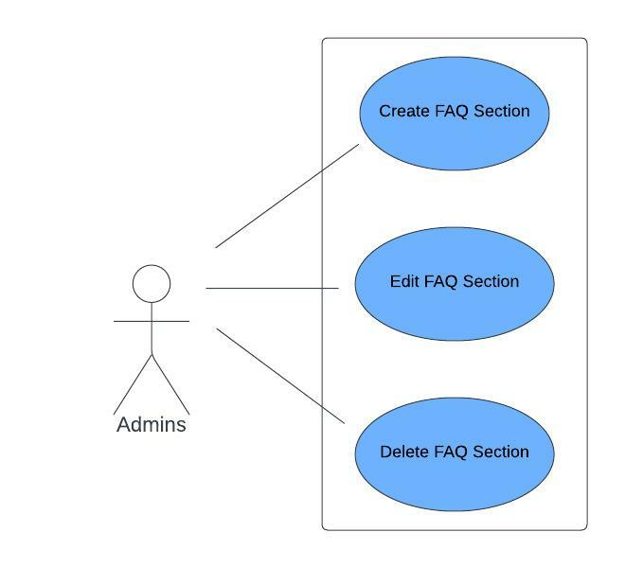
This diagram shows that admins are able to create, edit, and delete FAQ sections from the website.

Use Case 45 and Use Case 46:
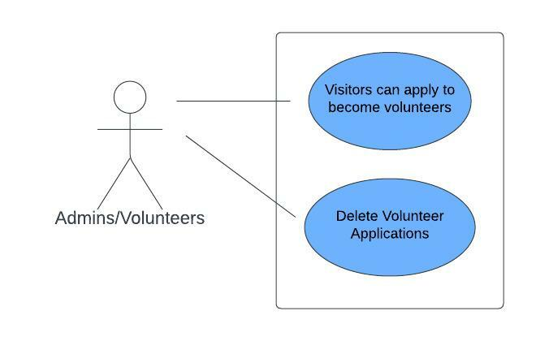
Lastly, this diagram shows that users can apply to become volunteers, and admins can delete volunteer applications if necessary.

Gantt Chart
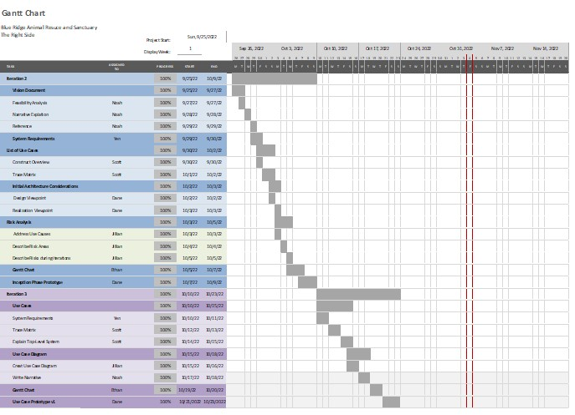

Use Case Prototype
The main high risk use case that must be considered is related to the donation system. The use cases that are associated with the donation system are: Create Donation, Edit Donation, Delete Donation, and Edit Payment. The two high risk cases are delete donation and edit payment. Deleting a donation means that potential donors end up giving up the donation payment, and editing payments can also present a risk of donating less than the predetermined lowest amount.

Example of donation custom amount option and cancel option that may present some risk of donors changing their mind or donating a lower amount:

Donation Amount
$5
$50
$20
$10
$100
Other Custom Amount:
$
Donate
Cancel

Another risk in use cases is related to the database system. Since admins are allowed to add, edit, and delete database items, it is possible to accidentally delete vital information. It is necessary to back up constantly, before initiating any action. ShelterLuv’s database does have automatic backup but manual backups are also recommended.

ShelterLuv database system’s example of deleting a record:
