Lab - Linux Firewall
- This is an individual assignment and worth 5 points.
- The due is tonight.
- Submit the outcome file. Follow the naming convention.

Task 1
- On Kali, create a rule that blocks ping requests to the Kali machine.
- Go to the host machine and ping the Kali. Take a screenshot of the output on the host machine.
- On Kali, display the rule you created. Take a screenshot of the output.
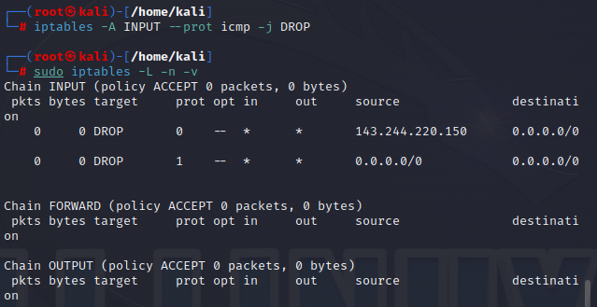

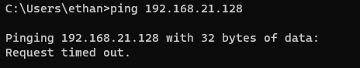

Task 2
- On Kali, launch Firefox and visit hurmfamilydentistry.com. Make sure the website is displayed properly.
- Create a rule that blocks access to this site. On a separate tab of the browser, visit the site again and show in a screenshot that the site now is not accessible.
- Display the rule you created. Take a screenshot of the output.
(Hint: watch the 2nd video in Tutorial 1).

