Lab: Ownership Chain
- This is an in-class lab and due tonight.
- Use the following naming convention: homework, underscore, last name, first initial, and extension (e.g., Lab_Ownchain_ImG.docx).

Provide the answers in light of ownership chains.
- (Task 1) Show the outcome of this task in a screenshot. Also, explain briefly why you have received the result.
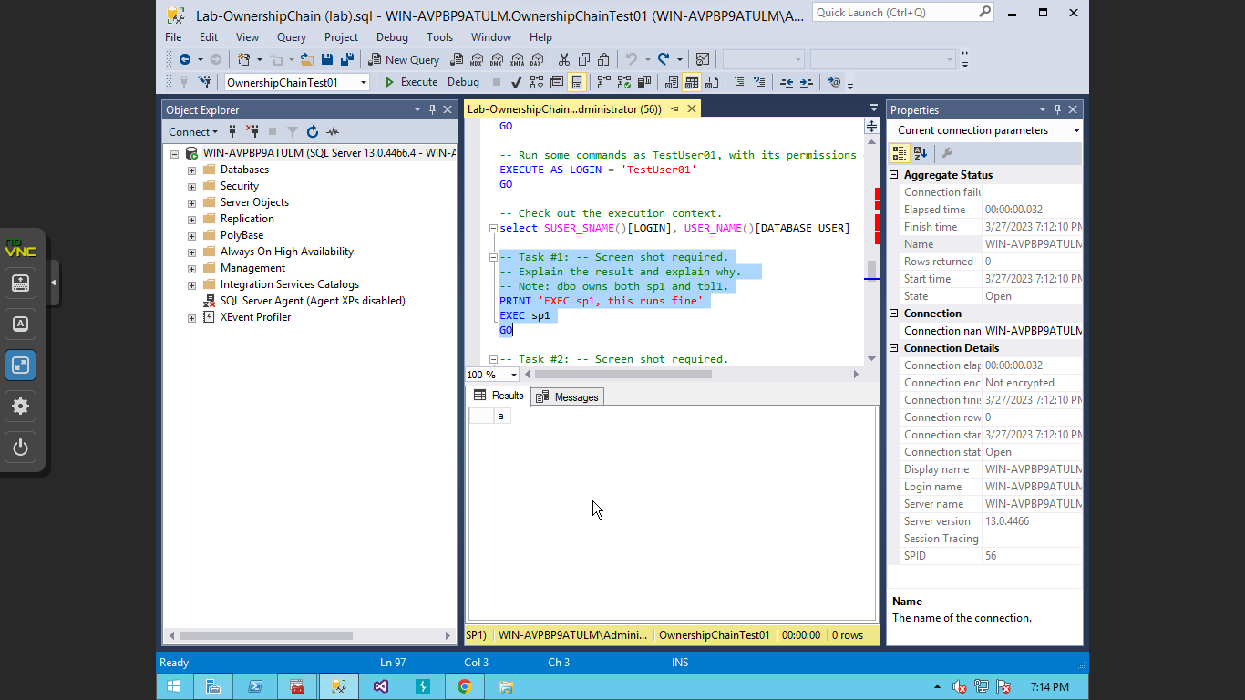

I received the result because through the code, the test user is granted to execute the stored procedure “sp1” which outputs the letter a.

- (Task 2) Show the outcome of this task in a screenshot. Also, explain briefly why you have received the result. 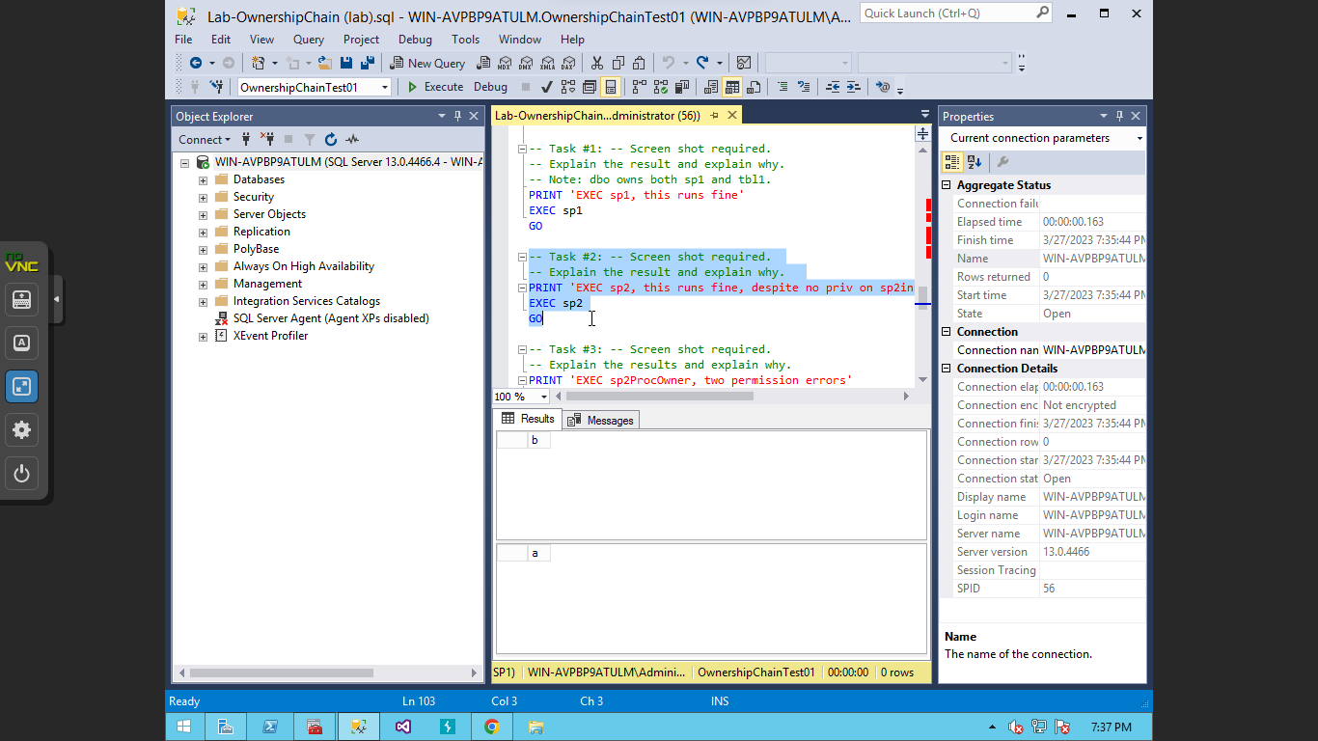
The outcome of the query is the letter A, and the letter B in the bottom half. This is because the test user has the privileges to execute sp2 which outputs the letter B but also executes sp2inner which outputs the letter a. The reason that the user is able to execute sp2inner without permissions is because it is embedded into the procedure in which they do have permission to run.

- (Task 3) Show the outcome of this task in a screenshot. Also, explain briefly why you have received the result. 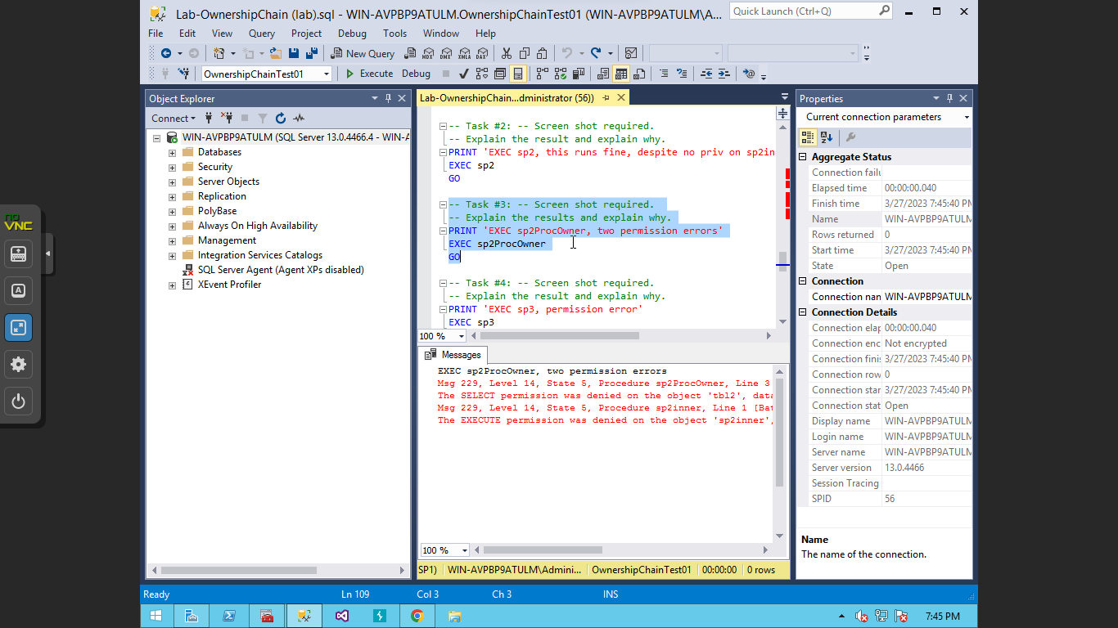
Since sp2procowner is owned by someone other than the test user, the test user is unable to execute the procedure along with the embedded procedures within it as well.

- (Task 4) Show the outcome of this task in a screenshot. Also, explain briefly why you have received the result. 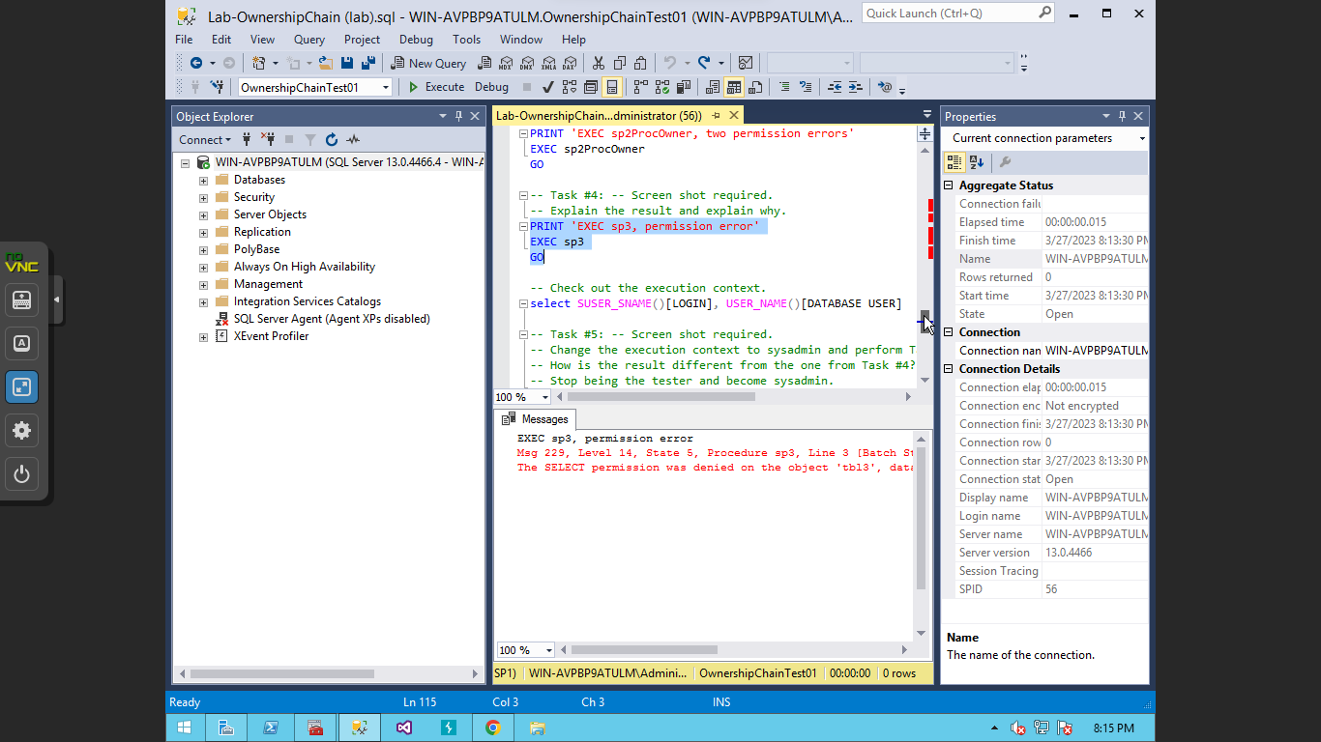
There is a permission error for executing sp3 because the owner of the sp3 is not the test user and is only connected to table 3 in which the test user does not have access to.

- (Task 5) Show the outcome of this task in a screenshot. Also, explain briefly why the result is different from the one from Task #4? 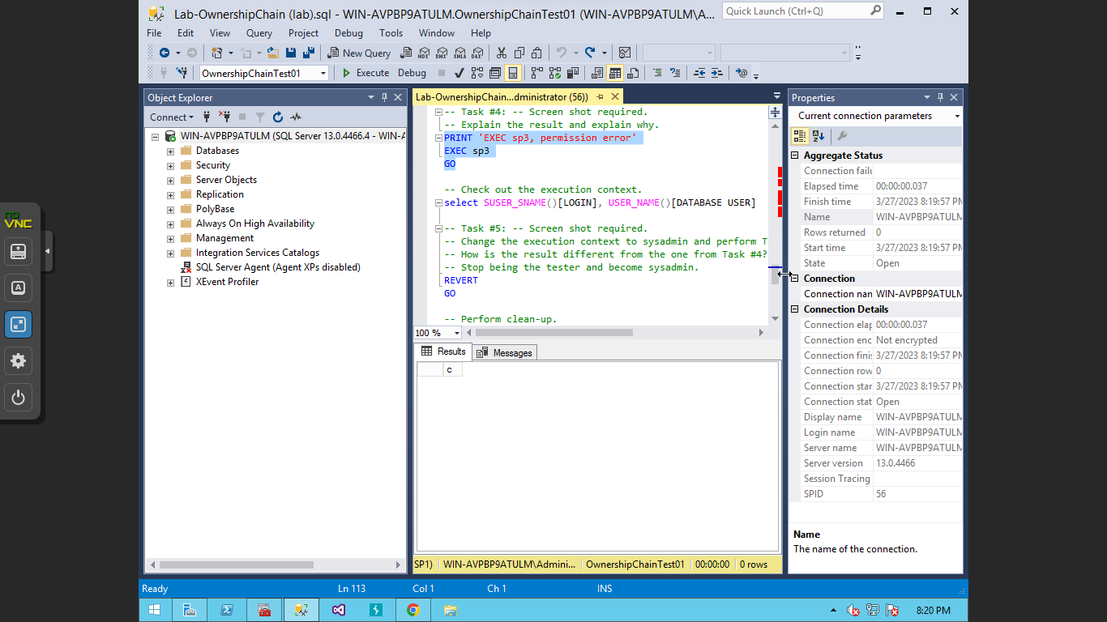

The output is different from task #4 because the query was able to be executed. When the system switched to the system administrator the user was able to execute the query because it bypassed all the permissions that were given to the test user.

